SUBJECT: INITIAL REVIEW OF DRAFT LONGVIEW ACE PERMIT
TO: JOANNE SPALDING
FROM: BRUCE BUCKHEIT
The West Virginia Department of Environmental Protection (DEP) has released a draft “construction” permit for public comment. DEP identifies this as complying with the ACE rule, but notes that there is no statue, regulation, or rule at either the State or Federal level that specifically requires Longview Power (LVP) to submit this application and that the application is viewed as voluntary on LVP’s part. In recent months LVP has come out of its second round of bankruptcy proceedings and turned over ownership to a group of secured creditors. Additional loans have been secured to allow ongoing operations – but only in the amount of $40 million over 5 years. So the first question is why would LVP burn cash now retain an engineering firm (Black & Veatch) to prepare an analysis and draft permit? The most likely answer is to provide comfort to investors and lenders. The draft permit specifically sets out that no additional expenditures will be required at Longview under the ACE rule
“Additionally, since the unit has demonstrated implementation of all BSER (or equivalent), no performance enhancement is required or anticipated.” – “DEP ENGINEERING EVALUATION/FACT SHEET” at p. 25
INITIAL STRINGENCY:
The technical support document cites to a Black & Veatch review (not yet obtained) and the judgment of the permitting engineer to conclude that the plant already has adopted BSER or need not adopt BSER because it is infeasible. LVP reports that its average annual net emission rate (including operation at all loads) over the past 10 years was 1,923 lb/MWh (net). This includes years, including 2014, where the facility claimed operational failures that increased emissions. The emission rate in the most recent year (all loads) is reported to be 1,899 lb/MWh (net).
Table 1 – Summary of the Carbon Dioxide Emissions from Longview Power
Operating Year | 2012 | 2013 | 2014 | 2015 | 2016 | 2017 | 2018 | 2019 | 2020*
CO2 Rate lb/MW-  Net | 1,837 | 1,882 | 1,999 | 1,944 | 1,946 | 1,947 | 1,921 | 1,899 | 1,936
CO2 Mass Rate (tpy) | 3,819,482 | 4,135,978 | 3,698,311 | 2,970,427 | 5,140,293 | 4,577,297 | 5,012,221 | 4,988,555 | 2,165,146

The draft permit stratifies net emissions data into load bins and sets emission limits based on the load of the unit. It sets these limits by determining the average monthly emission rate within the load bin and adding to that figure 2 times the standard deviation of the monthly data. This might be appropriate if one were setting a monthly limit, but DEP proposes an annual limit. The variability in annual data will ordinarily be less than that of monthly (or more frequent) data.
Load Bin | Load Bin Range (MWh G) | Normal Operation Level 1 Limit*  (lb CO2/MWh Net) | Impaired Operation Level 2 Limit**  (lb CO2/MWh Net)
LB-0 | 0-313 | 9,864^{G} | N/A
LB-1 | >313-407 | 2,230 | 2,453
LB-2 | >407-501 | 2,108 | 2,319
LB-3 | >501-595 | 2,050 | 2,255
LB-4 | >595-689 | 2,002 | 2,202
LB-5 | >689 | 1,958 | 2,154

As a baseload unit (still), Longview most often operates in LB-5. And so it can be seen that immediately post- implementation of BSER, the allowable emission rates are less stringent that recent, pre-ACE performance. The proposed permit also allows a substantially increased emission rate if the unit moves into a load-following regime and is therefore subject to the less stringent limits of the lower load bins. Note that the proposed permit would allow the facility to emit at rates above the proposed limit if “impaired” by an equipment malfunction that required substantial time to resolve.
DEGRADATION FACTOR:
As Longview’s AMPD data show, after the initial technical issues were resolved in 2014-2015 the unit’s average CO2 emission rate has trended downward. This may be the result of some capital improvements (including intelligent sootblowing) implemented in 2014-2015.
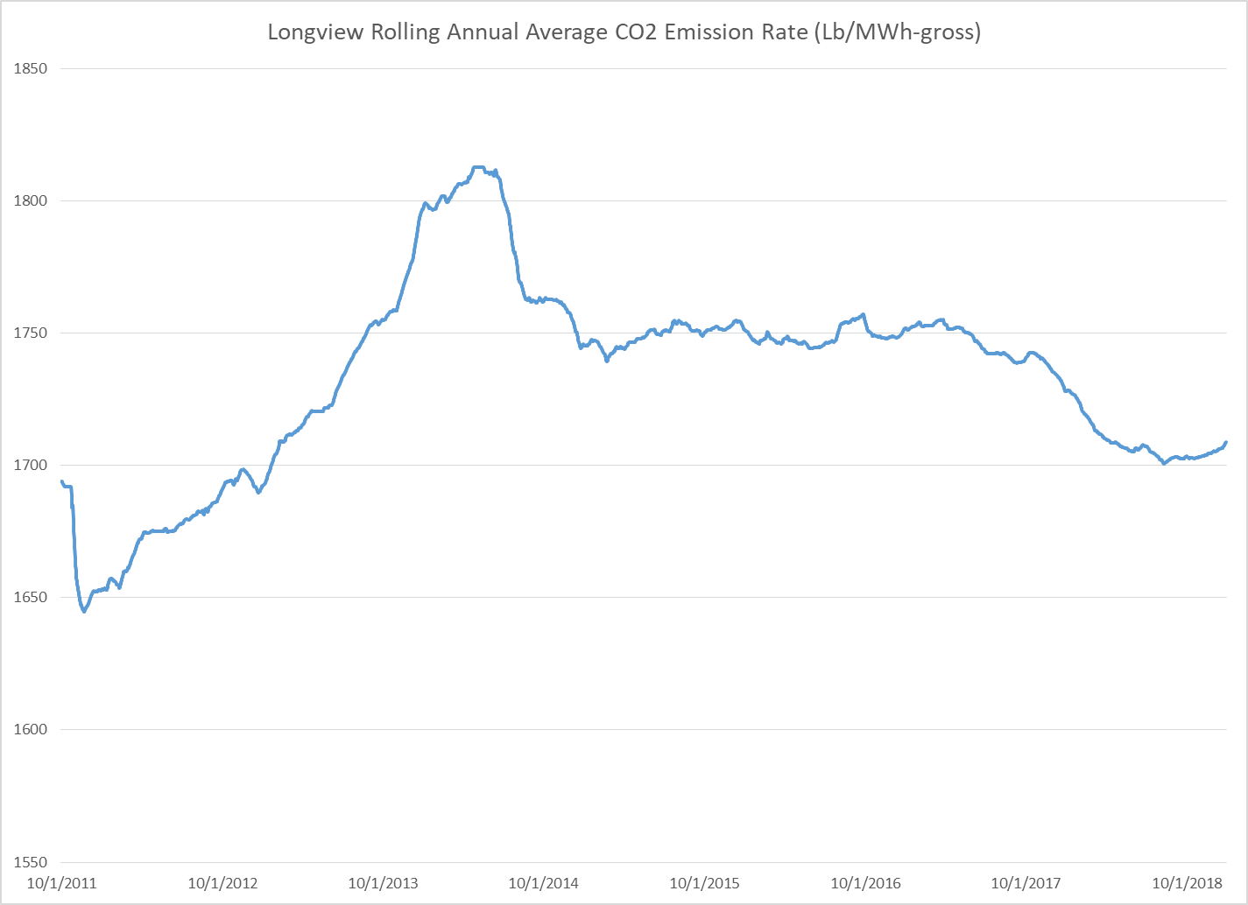
LVP’s Monthly heat rate data also support a finding that a degradation in performance of the unit over the next decade is not inevitable with proper response actions by the operator.
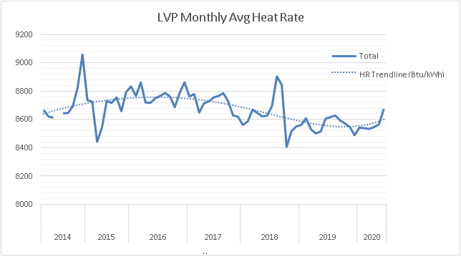
The draft permit ignores these data – and the net emissions data reported by LVP above and instead looks at the degradation in heat rate over time of other supercritical units. However, most of our supercritical units were built in the 1970s and so, are very much older than Longview. Black and Veatch apparently acknowledge a degradation at 40+ years. Further, the data reviewed reflect the performance of those units in the absence of a legal obligation to achieve and maintain a specified heat rate.
After the initial compliance year, the limits increase by 0.4% annually, supposedly to compensate for unit degradation, with a recovery rate that decreases the limit by 0.7% once every five years. Essentially this represents an average increase of 0.26% per year over each of the next 25 years. At current generation rates this would result in an increase of 13,000 tons in the first year over the prior years’ emissions. Importantly, the draft permit allows those increases to compound year-over-year. Thus, in year two, the increase would be 26,000 tons over baseline, increasing each year until 2046 when the annual increase in allowable emissions (at current generation rates) would be in excess of 320,000 tons per year. The sum of the increases allowed by the proposed degradation factor during the period would be nearly four million tons at current generation levels. In the year 2046 (and thereafter), the proposed limits would be:
Load Bin | Load Bin Range (MWh G) | Normal Operation Level 1 Limit*  (lb CO2/MWh Net) | Impaired Operation Level 2 Limit**  (lb CO2/MWh Net)
LB-0 | 0-313 | 10,523^{G} | N/A
LB-1 | >313-407 | 2,379 | 2,617
LB-2 | >407-501 | 2,249 | 2,474
LB-3 | >501-595 | 2,187 | 2,406
LB-4 | >595-689 | 2,136 | 2,349
LB-5 | >689 | 2,089 | 2,298

The proposed emission limit in 2046 for the most common (and efficient) load bin is 150 lb/MWh higher than the average of 2012-2019 emissions over all loads.
BASIS FOR DETERMINATION
The DEP Engineering Evaluation lists each of the categories of EPA’s ACE BSER and dismisses them as follows:
Neural Network/Intelligent Sootblowing
DEP CONCLUSION:
“LVP installed the intelligent sootblowing system and upgraded the neural network distributed control system (DCS) in 2015. Also, LVP installed an intelligent combustion system in 2018. Thus, the [intelligent sootblowing] system reduced the unit heat rate by 90 Btu/kWh….Since LVP has already installed these HRI technologies, no further evaluation of the technical and or economic feasibility of these technologies is necessary”.
COMMENT:
It appears that the intelligent sootblowing system performed better than EPA’s estimated range would suggest. However, there is no evaluation as to whether the “intelligent combustion system” is a BSER-level of application of the technology.
Air heater and duct leakage control
DEP CONCLUSION:
“LVP claims that their original air heater seal design meets the intent of the HRI under Subpart UUUUa. The writer agrees with the applicant that the intent of the HRI under Subpart UUUUa was to reduce leakage through the seals and repair ductwork by replacing worn out seals, make improvements to the seal design, using better materials for the seals (i.e. from single to double seals, wear resistance materials, adjustable seals) and repair ductwork. The writer concurs that LVP has implemented the HRI technology in their unit.”
COMMENT:
The intent of HRI is to improve heat rates at existing units. All heaters have seals and all duct work has some amount of leakage. No data concerning the performance of the heaters and duct leakage was reviewed by DEP. Nor did DEP evaluate what technical improvements were available.

VFDs (variable frequency drives) on the Boiler Feed Water Pumps
DEP CONCLUSION:
“This technology would adjust the work performed throughout the loads. At low load operations (475 MW gross), this HRI technology could reduce the auxiliary load consumption from the boiler feed water pumps by 3.9 MW. This technology does not reduce the unit’s heat rate at full load conditions.
LVP estimated that the capital cost of implementing this technology to their unit would be $12.65 per kW, on a gross basis. This capital cost exceeds the maximum projected cost in the Sargent & Lundy, Coal-Fired Power Plant Heat Rate Reductions, SL-009597 Final Report, January 22, 2009. (EPA-HQ-OAR-2017-0355-21171) of $8.50 per kW adjusted to 2020 dollars from 2008. The annual operation and maintenance costs were estimated to be $9,000 for all three pumps.
The unit only operated at loads less than 695 MW during the proposed baseline period (2016 to second Quarter of 2020) for only 10% of the operating time, which does not include startup and shutdown periods (loads less than the unit’s minimum load of 313 MW gross). These pumps operate near their highest efficiency point at full load, thus there Is no potential savings at low load, even with the fluid drives still in place. Given the high capacity factor of the unit, the practical annual potential HRI is low (0.19 percent), especially given the high cost of the VFDs. The writer concurs with LVP’s evaluation that implementing this technology on the boiler feedwater pumps is not reasonable due to the projected cost.”
COMMENT:
- We do not yet have LVP’s cost estimate to determine whether it is reasonable;
- It is likely that over time this unit will increase its hours of operation at less than full load. If part-load operation is so unlikely, there is no need to establish 6 bins of emission limits;
- This assessment is inconsistent with the later assertion that no technologies were rejected simply on the basis of cost;
- The now 11 year old estimates by Sargent & Lundy were never intended to constitute a safe harbor and do not substitute for case law respecting what costs are considered too high.
VFDs on the Induce Draft Fans
DEP CONCLUSION:
“In B&V’s evaluation of the feasibility of implementing the VFD technology to the forced and induced draft fans at LVP, the cost of the technology was reduced to terms that EPA used to justify the associated cost of the technologies in the ACE Rule² from the Sargent & Lundy Report, which is dollars per kW. The projected cost for LVP to employ the VFD technology to the forced draft fans is $3.10 per kW. The projected cost to add VFD to the induced fans is $4.60 per kW, which makes the overall cost of adding the VFD technology to the existing fans $7.70 per kW. Adjusting the cost range from the Sargent & Lundy report to 2020 dollars for the VFD technology, the projected cost of the VFD technology is within EPA’s reasonable expected cost range.
The potential HRI however is not within EPA’s expected range³. B&V has estimated that this technology could improve heat rate for LVP by 0.06% at full load and 0.08% at low operating load conditions. This expected heat rate improvement is less than the low end of EPA’s expected range of 0.2% for VFD technology.
In the ACE Rule, EPA noted that the VFD technology would be an ideal choice for applications with centrifugal fans on units that are load cycling (load following)⁴. The writer agrees this is EPA’s ideal application for this technology. LVP’s unit configuration and operational mode does not fall within this ideal application for the VFD technology.
Axial fans, in general, are more efficient than centrifugal fans. Coupling an axial fan with variable pitch blades is very efficient over an entire operating range. Thus, the expected HRI is not observed when adding VFD technology to LVP’s fans. The writer believes that VFD technology is not feasible for LVP’s forced- and induced-draft fans.”
COMMENT:
DEP is establishing emission limits through 2046 and beyond. It is highly unlikely that this unit will continue as a baseload unit throughout this timeframe. Longview’s poor economic performance last winter strongly suggests that part load operation will increase over past practices. Just as DEP assigned more lenient emission rates for part load operation, it could also assign more stringent HRI to complement those rates. The report that applying this technology at low load would yield only 0.08% improvement is inconsistent with the literature and needs documentation.
Blade path upgrades for steam turbines
DEP CONCLUSION:
“Siemens claims that the SST-6000 package has over a 48% efficiency. As of June 2015, there are 488 units of the SST-6000 package series operating worldwide. Currently, Siemens does not offer any blade path improvement option for the SST-6000 series. Therefore, the blade path upgrade HRI technology is not a feasible option for LVP’s SST-6000 turbine package.”
COMMENT:
DEP does not appear to have reviewed any performance data for the Longview turbine. At this stage in its lifetime, the unit might be due for a refit or replacement.
Redesign/Replacement of the Economizer
DEP CONCLUSION:
In the application, LVP claims their original design and constructed economizer is sized correctly for their unit. Redesign of the economizer would not allow the unit to take advantage of any gains in the unit’s heat rate without adversely effecting downstream pollution control devices or increasing the degradation of downstream ductwork and other pieces of equipment.
The writer agrees with the applicant that a redesigned economizer would not offer any HRI without affecting the unit’s ability to control NOx emissions. Should LVP consider redesigning the economizer, LVP’s redesign would need to evaluate whether the proposed upgrade would affect the performance of the SCR and would this performance change trigger major modification of major source permitting requirements under the New Source Review Program of the Clean Air Act.
COMMENT:
It is not surprising that improving the efficiency of the economizer might trigger a need to redesign the bypass to the SCR. DEP identifies a technical issue, but does not conclude that this technique is infeasible. Notably, DEP provides neither an estimate of the potential efficiency gain nor the cost.
Improved Operating and Maintenance (O&M) Practices
DEP CONCLUSION:
“LVP cannot quantify the actual improvement in their HR to these listed O&M improvement values. This OPM HR data clearly suggests that these efforts, on a collective basis, are improving the unit HR. Over time, key components or equipment will wear down over time. As result of the wear and tear of components such a pumps and turbine blades, the NPHR of a unit will increase which is referred to as unit degradation. LVP expects that the trend line in Figure 9 to continue to climb with period of decreases when these key components are repair, which LVP plan to conduct once every five year of minor repair outages and major turbine repair work to be conducted once every ten years. These minor and major maintenance outages it to minimize this unit degradation as much as possible.
Several of the O&M measures that LVP has implemented monitors the preformed of the critical components which allows LVP to properly allocate resources and martials for the minor and major repair outages in effort to regain the unit efficiency (heat rate).
LVP has noted many programs, activities, and training as HRI under the O&M category. Being trained, adding an improvement program, or redesigning a piece of equipment to the latest technology does not always improve the heat rate of any unit.
LVP has adopted all of the measures that EPA noted in the ACE Rule, which include HRI training for O&M staff, perform on-site appraisals to identify areas for improved heat rate performance, and improved steam surface condenser cleaning. The writer believes there is no additional HRI for the O&M technology category that can be employed.”
COMMENT:
DEP offers a number of general conclusions but does not provide any specifics as to the nature and rigor of LVP’s O&M practices, how they differ from those at other plants and why they are BSER. The list of practices that should be evaluated is lengthy. See SC comment on O&M practices for additional detail.

CONCLUSIONS of the HRI Evaluations
DEP CONCLUSION:
LVP concluded, after evaluating these seven HRI technologies, that their unit has no potential benefit (reducing the unit’s heat rate) from any of these technologies as listed in Subpart UUUUa of Part 60. EPA did anticipate that the most efficient units would have little to no potential heat rate improvement when applying the BSERs. The writer concurs with this assessment.
COMMENT: No comment.

Given this, what is DEP’s authority to act? They cite to 45 C.S.R. 13, the closest basis would seem to §4.2.a.5. “Change in a permit condition to incorporate any new more stringent requirements related to new information not considered at the time the existing permit was issued;”
It is interesting to note that even though Longview is one of the newest and most efficient (supercritical) units in the country, and even though its initial debt was presumably reduced in the first bankruptcy, LVP blamed the second bankruptcy on one warm winter.
We will need to see what DEP has placed in the docket.
The reported emission rate for 2011-2012 is infeasible and likely the result of improper calibration of the CEMS.
Note: the “trend line” in this chart is an artist’s flourish, unsupported by the data. It overemphasizes the first few months of 2020.
There are four or five relatively new SC or USC units.

