Dog reduces wildlife, aircraft encounters at West Virginia airport
By RICK STEELHAMMER, THE CHARLESTON GAZETTE-MAIL
ASSOCIATED PRESS |
AUG 25, 2020 AT 3:01 PM
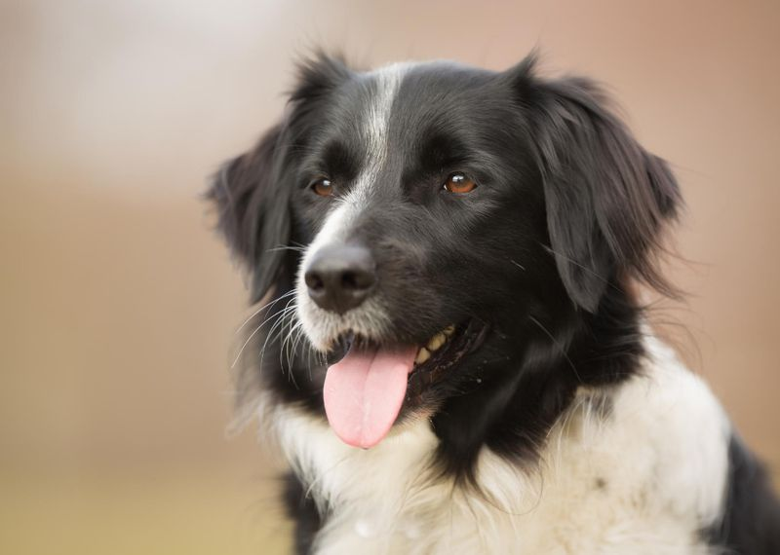
Border collies are considered to be one of the most intelligent dog breeds. This trait allows them to excel at sheepherding, which these dogs were originally bred for. Though they may seem happy-go-lucky and adorable to owners, border collies are known for staring down a flock of sheep to intimidate them into obedience.
CHARLESTON, W. Va. (AP) — Hercules, the 3-year-old border collie charged with keeping birds and other forest-dwelling animals off Yeager Airport’s runways and taxiways, is credited with dramatically reducing the number of wildlife strikes to aircraft at the Charleston airport, including a rare strike-free three-month period.
Since joining the staff at Yeager in October 2018 after undergoing training in wildlife management protocols, Hercules has made 2- to 3-mile patrols of the airport's operations area each day to keep animals out of the path of aircraft.

Like other U.S. airports, birds make up the majority of wildlife strikes at Yeager, and Hercules is more than happy to chase them out of harm's way -- for both flight crews and feathered fliers.
During the third quarter of the 2020 fiscal year, when the no-strike period took place, Hercules chased or otherwise harassed nearly 900 birds and other animals to keep them away from aircraft, according to data collected by the U.S. Department of Agriculture. The USDA has a longstanding wildlife management agreement with the Charleston airport.

"Wildlife strikes can bring a plane down," said Nick Keller, Yeager Airport's CEO. "That is why we take this issue seriously, and why we have our wildlife dog Hercules. To have zero strikes three months in a row is incredible."
"Bird strikes are dangerous because birds usually fly in fig flocks," said Russ Kennedy, Yeager's operations manager. Birds can cause serious mechanical issues if they "can get into a jet engine or other parts of a plane," Kennedy said.
Hercules makes his rounds in the company of a new full-time wildlife management specialist.
Bird strikes to commercial aircraft at Yeager Airport in 2019 included two incidents involving hawks, one involving cuckoos, and single-bird incidents involving a chimney swift and a ruby crowned kinglet, according to an FAA wildlife strike database. None of those bird strikes caused damage to the aircraft.
Prior to Hercules' tenure at the airport, wildlife strikes have included at least two coyotes, two deer, three bats, three geese and a yellow bellied sapsucker. The only strike resulting in significant damage to an aircraft was one of the deer encounters, according to the FAA data.
"We are so proud of Hercules," Keller said. "He has an incredibly important job and he does it very well."
Hercules was bought and trained with a $7,500 allocation from the Kanawha County Commission.

L

