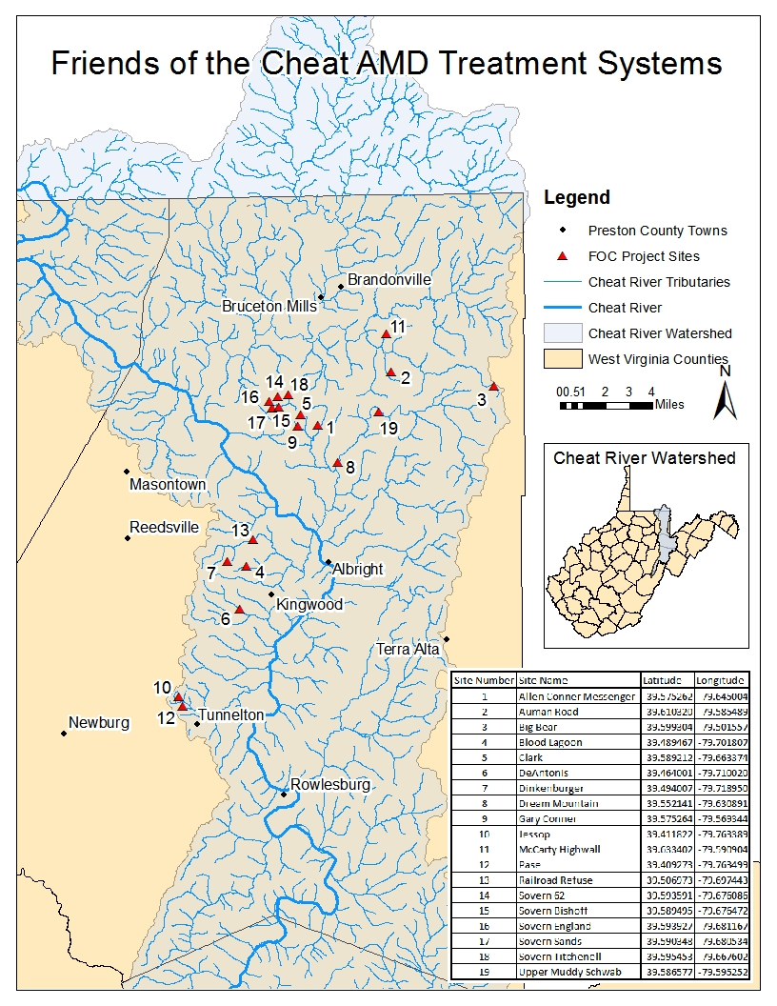

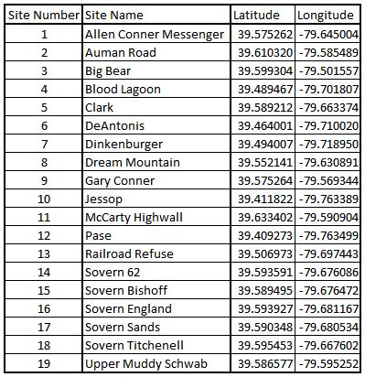
Data included in this report for Friends of the Cheat’s monitoring program has been funded (in part) by the United States Environmental Protection Agency, West Virginia Department of Environmental Protection’s Watershed Improvement Branch, United States Office of Surface Mining, and the Stream Partners Program.

Project: Allen Conner Messenger
Stream: Glade Run | Martin Creek | Muddy Creek
Coordinates: 39.575262, -79.645004
Year completed: 2012
Total construction: $228,095 (Alpha Associates/CE Bolyard & Son)
Description: Three independent auto-flushing limestone leach beds were constructed to treat three
AMD sources. Due to space limitations, no settling ponds were constructed. The ponds are set to flush on a staggered schedule so that only one pond is flushing at a time.
Expected results: Target 80-85% removal of acidity (245 TPY), iron (4.3 TPY) and aluminum
(29.94 TPY), and manganese (5.3 TPY)
Water quality data: (07/23/2021), (07/29/2021)
Site | Flow (GPM) | Conduct. (µs) | Lab pH (SU) | Acidity (mg/L) | D_Al (mg/L) | D_Fe (mg/L) | D_Mn (mg/L)
ACM 1 SO –07/23/2021 | 0 | - | - | - | - | - | -
ACM 2 SO –07/29/2021 | 15.859 | 1854 | 3.61 | 228.6 | 28.4 | 2.63 | 3.96
ACM 3 SO –07/23/2021 | 24.51 | 1166 | 4.53 | 121.6 | 15.0 | 2.31 | 1.75
GR us ACM –07/23/2021 | 230.23 | 847.3 | 3.91 | 104.3 | 13.0 | 1.79 | 1.87
GR ds ACM -07/23/2021 | 289.92 | 1086 | 4.03 | 137.6 | 11.9 | 1.91 | 1.98

Project: Auman Road
Stream: Beaver Creek | Little Sandy Creek | Big Sandy Creek
Coordinates: 39.610320, -79.585489
Year completed: 2020
Total construction: $296,338.00 (Engineering: CEC, INC, Construction: Solid Rock Excavating, INC)
Description: The site currently consists of two small impoundments and AMD seeps from land
reclaimed in 1996. The conceptual design includes open limestone channels, a flushing limestone leach bed, a settling pond, and a wetland.
Expected results: 80% removal of pollutant loads. Current loads- acidity: 50 TPY, aluminum: 7
TPY, iron: 1.3 TPY, manganese: 1.9 TPY.
Water quality data: (9/29/2021)
Site | Flow (GPM) | Conduct. (µs) | Lab pH (SU) | Acidity (mg/L) | D_Al (mg/L) | D_Fe (mg/L) | D_Mn (mg/L)
Auman Pond #1 | - | 462 | 3.89 | 40.33 | 4.5 | 0.609 | 2.23
Auman L CB | - | 570 | 3.51 | 65.6 | 5.49 | 5.34 | 3.34
Auman L WL | - | 505 | 7.7 | -36.8 | 0 | 0 | 0.927
BC at Auman Rd | 7064.11 | 111 | 7.35 | -9.21 | 0 | 0 | 0.077
Auman Trib at Auman | 512.98 | 152 | 7.32 | -4.99 | 0.0859 | 0.342 | 0.317

Project: Big Bear
Stream: Beaver Creek | Little Sandy Creek | Big Sandy Creek
Coordinates: 39.599304, -79.501557
Year completed: 2000; 2015
Total construction: 2000: $108,866 (Alpha Associates/Ground Breakers); 2015: $93,477
(Alpha Associates/Williams Excavating)
Description: 2000: Water quality is degraded by exposure to sandstone bedrock, acid deposition,
and a large headwater wetland which contributes acidity. A limestone leach bed was constructed to add alkalinity. After approximately two years, it became clogged and inefficient due to lack of sediment control. 2015: The limestone leach bed was replaced and an Agri-drain and flush pipes were installed.
Expected results: Add alkalinity to Beaver Creek
Water quality data: (9/10/2021)
Site | Flow (GPM) | Conduct. (µs) | Lab pH (SU) | Acidity (mg/L) | D_Al (mg/L) | D_Fe (mg/L) | D_Mn (mg/L)
BB SI | 3.411 | 24.3 | 6.61 | 9.58 | 0 | 0.47 | 0.0463
BB SO | 3.348 | 105 | 7.55 | -9.09 | 0.0985 | 0 | 0.0139

Project: Blood Lagoon
Stream: Middle Fork Greens Run | Greens Run
Coordinates: 39.489467, -79.701807
Year completed: 1995, 2002; 2007
Total construction: 1995: $250,000 (Anker Energy); 2002: $62,750 (Triad Engineering); 2008:
$224,079 (Alpha Associates/CE Bolyard & Son)
Description: 1995: Anoxic limestone drain (ALD) was installed to treat AMD from seep #3. Half
of the iron and all of the aluminum precipitated in the drain. ALD was plugged within one year. 2002: A steel slag system was constructed, but filled with sludge. 2008: A large steel slag leach pond, limestone leach beds, and settling ponds, which were constructed.
Expected results: 2002: Increase pH from 3.0 to 5.5. 2008: Reductions of iron (61 tons),
aluminum (23 tons), and manganese (2 tons).
Water quality data: (10/20/2021)
Site | Flow (GPM) | Conduct. (µs) | Lab pH (SU) | Acidity (mg/L) | D_Al (mg/L) | D_Fe (mg/L) | D_Mn (mg/L)
BL SO | 14.59 | 2,040 | 2.6 | 768 | 61.7 | 76 | 4.98

Project: Clark
Stream: Sovern Run | Big Sandy Creek
Coordinates: 39.589212, -79.663374
Year completed: 2005
Total construction: $71,600 (Triad Engineering/CE Bolyard & Son)
Description: Land reclamation including the installation of mine seals took place in the 1990s. In
2005, Sovern Run was channeled into a composite steel slag and open limestone v-shaped ditch to provide passive treatment. An additional steel slag check dam was installed at the outlet of an unnamed tributary of Sovern run near the downstream end of the project site. *Due to landowner issues, FOC has not visited the site since 2009.
Expected results: Reduction of pollutants: acid (57 TPY), iron (0.84 TPY), aluminum (5.1
TPY), and manganese (0.4 TYP).
Water quality data: (11/20/2009*)
Site | Flow (GPM) | Conduct. (µs) | Field pH (SU) | Acidity (mg/L) | D_Al (mg/L) | D_Fe (mg/L) | D_Mn (mg/L)
Clark SO | 10 | 490 | 6.14 | 6.02 | 0.24 | 0.44 | 0.69
Clark BOLC3 | 11 | 650 | 3.63 | 52.85 | 2.13 | 8.75 | 3.19
Clark abv Dam | - | 140 | 6.9 | - | - | - | -

Project: DeAntonis
Stream: Morgan Run
Coordinates: 39.464001, -79.710020
Year completed: 2007; 2009
Total construction: 2007: $102,588 (Alpha Associates); 2009: $43,650 (Alpha Associates/CE
Bolyard & Son)
Description: 2007: A limestone leach bed was constructed at the draining portal. Freshwater was
directed through a steel slag leach bed. A sludge pond allowed mixing and precipitation from both leach beds. 2009: A freshwater basin installed to supply steel slag bed and limit sedimentation. Sludge was also removed and disposed of at T&T #3.
Expected results: Reductions of 25,459 pounds/year of iron, 6,780 pounds/year of aluminum,
883 pounds/year of manganese.
Water quality data: (6/1/2020)
Site | Flow (GPM) | Conduct. (µs) | Field pH (SU) | Acidity (mg/L) | D_Al (mg/L) | D_Fe (mg/L) | D_Mn (mg/L)
DeAnt SO | 28.371 | 1363 | 2.76 | 384.3 | 25.1 | 44.7 | 1.74

Project: Dinkenberger
Stream: North Fork Greens Run | Greens Run
Coordinates: 39.494007, -79.718950
Year completed: 2003; 2011
Total construction: 2003; 2011: $113,591 (Alpha Associates/Williams Excavating, LLC)
Description: 2003: A small dike was constructed to improve a pool at the mouth of the portal.
Water discharged into a limestone leach bed, down a limestone rip rap channel, through a culvert under the road. A storm in 2005 clogged the leach bed with organic material. In 2006, the leach bed was wrapped in fabric to prevent further clogging. 2011: An auto flushing limestone leach bed replaced the original leach bed. Water discharges through a culvert under the road and flows through an open limestone channel with sheet piling prior to flowing into the stream.
Expected results:
Water quality data: (07/07/2021) *Assumed Dink SO flow = SI flow
Site | Flow (GPM) | Conduct. (µs) | Lab pH (SU) | Acidity (mg/L) | D_Al (mg/L) | D_Fe (mg/L) | D_Mn (mg/L)
Dink SO | 4.386* | 1230 | 4.24 | 207.3 | 27.9 | 1.36 | 4.48
Dink Trib ds SO | 16.611 | 485.1 | 3.95 | 82.16 | 5.38 | 1.29 | 2.33
Dink Trib us Known Seeps | 0 | - | - | - | - | - | -
Dink SI | 4.386 | 1741 | 2.8 | 858.3 | 67.1 | 149 | 7.99

Project: Dream Mountain
Stream: Muddy Creek
Coordinates: 39.552141, -79.630891
Year completed: 2012, Updates anticipated Jan 2021
Total construction: Phase I: $232,831.93 (Engineering: BioMost, INC, Construction: Blue Gold Development, LLC)
Description: Open limestone channels collect and convey water from five portals on the Dream
Mountain Game Ranch property to one common point (DM Comb Sources). Two freshwater tributaries are conveyed to a steel slag leach bed. Water mixes in a sludge pond prior to discharging through two constructed wetlands.
Expected results: 80% reduction of pre-construction loads. Removal of 416,416 pounds/year of
acid, 64,528 pounds/year of iron, and 4,016 pounds/year of manganese, as well as generating additional alkalinity.
Water quality data: (10/8/21)
Site | Flow (GPM) | Conduct. (µs) | Lab pH (SU) | Acidity (mg/L) | D_Al (mg/L) | D_Fe (mg/L) | D_Mn (mg/L)
DM Comb Sources | 41.021 | 1950 | 2.76 | 501.5 | 48.3 | 32.9 | 2.58
DM SO | 46.231 | 1460 | 3.76 | 93.26 | 12 | 1.07 | 1.76
MC ds DM SO | 2003.44 | 291 | 7.53 | -16.99 | 0.105 | 0 | 0.166
MC us DM SO | - | - | - | - | - | - | -
Muddy Mouth | 3608.35 | 673 | 7.34 | -9.57 | 0 | 0 | 0.795

Project: Gary Conner
Stream: Glade Run | Martin Creek | Muddy Creek
Coordinates: 39.575264, -79.659344
Year completed: 2011
Total construction: $411,227 (Potesta & Associates/CE Bolyard & Son)
Description: The site consist of several seeps of acidic water that combine into one drainage path.
Over a mile of open limestone channels collect the water and convey it to a limestone leach bed, settling pond, and aerobic wetland area. The project was designed by Potesta & Associates, Inc. *Due to landowner issues, FOC has not accessed between LSB 1 and Glade Run Road since 2012.
Expected results:
Water quality data: (01/14/2021)
Site | Flow (GPM) | Conduct. (µs) | Lab pH (SU) | Acidity (mg/L) | D_Al (mg/L) | D_Fe (mg/L) | D_Mn (mg/L)
GC Comb Seeps | - | - | - | - | - | - | -
GC LSB 1 | - | - | - | - | - | - | -
GC SO* | - | - | - | - | - | - | -
GC at GRR | 430.85 | 835.4 | 4.82 | 99.05 | 11.9 | 0.878 | 6.73

Project: Jessop
Stream: Pase Tributary | Pringle Run
Coordinates: 39.411722, -79.763389
Year completed: 2009
Total construction: $113,228 (Triad Engineering/CE Bolyard & Son)
Description: Open limestone channels collect seeps from two portals. A steel slag leach bed was
placed upstream of the portals in a freshwater channel to boost alkalinity. A limestone leach bed was constructed below the confluence of the AMD and freshwater.
Expected results: Reductions of 1,201 pounds/year of iron, 3,521 pounds/year of aluminum, and
323 pounds/year of manganese.
Water quality data: (10/20/2021)
Site | Flow (GPM) | Conduct. (µs) | Lab pH (SU) | Acidity (mg/L) | D_Al (mg/L) | D_Fe (mg/L) | D_Mn (mg/L)
Jessop SO | 12.617 | 976 | 3.05 | 182.3 | 19.4 | 2.82 | 1.69

Project: McCarty Highwall
Stream: Beaver Creek | Little Sandy Creek | Big Sandy Creek
Coordinates: 39.633402, -79.590904
Year completed: 2001
Total construction: $72,784 (Triad Engineering/Grafton Coal Company)
Description: Two seeps formed a small stream that flows south into Beaver Creek. Several other
small seeps are picked up by the UNT. A series of open limestone channels and a steel slag leach bed were constructed downstream of the first two seeps.
Expected results:
Water quality data: (9/17/2021)
Site | Flow (GPM) | Conduct. (µs) | Lab pH (SU) | Acidity (mg/L) | D_Al (mg/L) | D_Fe (mg/L) | D_Mn (mg/L)
MH SO | 18.218 | 438 | 7.44 | 8.03 | 0 | 0 | 0.763

Project: McElroy
Stream: Beaver Creek | Little Sandy Creek | Big Sandy Creek
Coordinates: 39.60632, -79.58763
Year completed: Projected 2020
Total construction: Estimated $174,600 – Engineering and Construction Design-Build. Design-Builder: BioMost, INC & Solid Rock Excavating, INC
Description: The site consists of three small impoundments and AMD seeps. The site has not been reclaimed nor is AMD currently being treated. The conceptual design includes open limestone channels, a flushing limestone leach bed, a settling pond. Engineering is expected to start in 2019.
Expected results: 80% removal of pollutant loads. Current loads: acidity (30,000 lbs/yr), aluminum (3,500 lb/yr), iron (150 lb/yr), manganese (1,000 lb/yr).
Water quality data: (7/15/2021)
Site | Flow (GPM) | Conduct. (µs) | Lab pH (SU) | Acidity (mg/L) | D_Al (mg/L) | D_Fe (mg/L) | D_Mn (mg/L)
McElroy Seep 1 | 0 | - | - | - | - | - | -
UNT ds McElroy | 43.08 | 190.3 | 7.78 | -3.31 | 0 | 0.365 | 0.245
UNT us McElroy | 38.15 | 190.9 | 8.02 | -4.42 | 0 | 0 | 0.0897

Project: Pase Active Treatment
Stream: Pase Tributary | Pringle Run
Coordinates: 39.409273, -79.763499
Year completed: 2004; 2006; 2012; 2017
Total construction: 2004: $142,150 (Triad Engineering/CE Bolyard & Son); 2006: $142,150;
2012: $341,064 (Skelly and Loy/CE Bolyard & Son); 2017: $99,979 (BioMost, Inc./Solid Rock Excavating)
Description: 2004: A vertical flow bioreactor was constructed in sequence with an anoxic
limestone drain. 2006: A limestone leach bed was added above the vertical flow bioreactor, new organic material was added to the vertical flow bioreactor, and rapid flushing valves were added to the ALD. 2012: A 70-ton lime dosing silo was installed to treat acidic mine water from a forebay, followed by two settling ponds and a constructed wetland. 2016: A MixWell, A-Mixer, and trompe were installed to increase mixing. Additionally, a sludge pump and sludge lines were installed.
Expected results: 2017: remove 100% of the acid load, reduce iron and aluminum loads by
greater than 95%.
Water quality data: (07/8/2021)
Site | Flow (GPM) | Conduct. (µs) | Lab pH (SU) | Acidity (mg/L) | D_Al (mg/L) | D_Fe (mg/L) | D_Mn (mg/L)
Pase WL Out | 22.67 | 760.1 | 6.92 | 2.23 | 0 | 0 | 1.71
Pase SI | 22.67 | 1071 | 2.99 | 231.4 | 21.2 | 6 | 2.34

Project: Railroad Refuse
Stream: North Fork Greens Run | Greens Run
Coordinates: 39.506973, -79.697443
Year completed: 2015
Total construction: $271,500 (BioMost/Solid Rock Excavating)
Description: Water is conveyed from three portals through an open limestone channel to an
oxidation precipitation channel, an auto-flushing limestone leach bed with syphon system, a settling pond, a mixed-media vertical flow pond, and constructed wetland.
Expected results: Discharge neutral pH, >1 mg/L aluminum, >5 mg/L iron, discharge additional
alkalinity
Water quality data: (07/07/2021)
Site | Flow (GPM) | Conduct. (µs) | Lab pH (SU) | Acidity (mg/L) | D_Al (mg/L) | D_Fe (mg/L) | D_Mn (mg/L)
RR WL Out | 1.13 | 441.5 | 7.84 | -37.86 | 0 | 0 | 0.279
NFG US RR | 157.53 | 124.6 | 5.03 | 16.59 | 0.832 | 0 | 0.285
NFG DS RR | 166.06 | 125.3 | 5.1 | 15.45 | 0.764 | 0 | 0.348
RR TOLC | 0.355 | 2040 | 2.85 | 1244 | 74.5 | 399 | 3.66

Project: Sovern 62 / Sovern Bishoff
Stream: Sovern Run | Big Sandy Creek
Coordinates: 39.593591, -79.676086
Year completed: 1998; 2003; 2010
Total construction: 1998: $50,665 (Triad Engineering/Grafton Coal Company); 2003: $12,772
(Grafton Coal Company); 2010: $235,139 (Alpha Associates/CE Bolyard & Son)
Description: 1998: Gravel sized limestone was pneumatically injected into the mine portal and a
dam was constructed to collect treated water. An open limestone channel was constructed below the pond. 2003: Steel slag was added to the pond and rip rap was added to the channel. 2010: A steel slag leach bed, open limestone channels, limestone separation dam, and series of settling ponds including a final wetland polishing pond were constructed. Additionally, a steel slag leach bed (“Bishoff”) was constructed.
Expected results: 80% reduction of Al, Fe, and acidity.
Water quality data: (06/29/2021)
Site | Flow (GPM) | Conduct. (µs) | Lab pH (SU) | Acidity (mg/L) | D_Al (mg/L) | D_Fe (mg/L) | D_Mn (mg/L)
Sov 62 SO | 10.522 | 834.4 | 3.35 | 153.4 | 17.4 | 4.01 | 2.4
Bishoff SO | 6.007 | 124.6 | 7.27 | -2.51 | 0 | 2.48 | 0.347

Project: Sovern England
Stream: Sovern Run | Big Sandy Creek
Coordinates: 39.593927, -79.681167
Year completed: Projected 2017
Total construction: Expected $169,525 ($340,181 including OALMR reclamation project)
Description: Land reclamation completed by OAMLR (Solid Rock Excavating) in 2016.
Hedin Environmental is working on designing and constructing a drainable limestone bed.
Expected results: Removal of 142 pounds/day of acidity, 8 pounds/day of aluminum, 2
pounds/day of iron, and 2 pounds/day of manganese.
Water quality data: (10/4/2021)*Asumme SI flow = SO flow
Site | Flow (GPM) | Conduct. (µs) | Lab pH (SU) | Acidity (mg/L) | D_Al (mg/L) | D_Fe (mg/L) | D_Mn (mg/L)
Sov Eng SI | - | 282 | 3.49 | 38.61 | 2.35 | 3.5 | 0.803
Sov Eng SO | 6.396 | 278 | 7.93 | -31.07 | 0 | 0 | 0
Sov Eng 006 | 15.959 | 257 | 7.95 | -48.14 | 0 | 0 | 0.106

Project: Sovern Sands
Stream: Sovern Run | Big Sandy Creek
Coordinates: 39.590348, -79.680534
Year completed: 2007; 2011
Total construction: ~$500/25 ton truck load of 97% calcium carbonate dust as needed
Description: Periodically, limestone fines are shoveled instream in Sovern Run in cooperation
with the landowner.
Expected results: Added alkalinity instream.
Water quality data: (10/5/2021)
Site | Flow (GPM) | Conduct. (µs) | Lab pH (SU) | Acidity (mg/L) | D_Al (mg/L) | D_Fe (mg/L) | D_Mn (mg/L)
Sov Sands US | 124.32 | 350 | 5.0 | 13.95 | 0.897 | 0.196 | 0.828
Sov Sands DS | 173.69 | 339 | 5.76 | 9.37 | 0.335 | 0 | 0.779
Sov Hudson | 205.1 | 306 | 6.63 | 6.87 | 0 | 0 | 0.476
Sov Mouth | 500.41 | 268 | 7.52 | -10.56 | 0 | 0 | 0

Project: Sovern Titchenell
Stream: Sovern Run | Big Sandy Creek
Coordinates: 39.595453, -79.667602
Year completed: 2005; 2015
Total construction: 2005: $174,420; 2015: $216,001 (Skelly and Loy/Solid Rock Excavating)
Description: 2005: An open limestone channel transported water to a limestone leach bed and a
steel slag check dam before discharging into a wetland. An acidic pond was treated by a similar limestone pond and steel slag check dam system. 2015: Steel slag in the upper area was removed and replaced with an auto-flushing limestone leach bed. The lower limestone leach bed was removed and replaced with a larger auto-flushing limestone leach bed. The lower steel slag bed was removed and replaced with a settling pond.
Expected results: Removal of 7.89 pounds/day of Al and 44.49 pounds/day of Fe.
Water quality data: (05/18/2020)
Site | Flow (GPM) | Conduct. (µs) | Lab pH (SU) | Acidity (mg/L) | D_Al (mg/L) | D_Fe (mg/L) | D_Mn (mg/L)
Titch L SP Out | 26.7 | 177.0 | 6.91 | 14.09 | 0 | 0 | 0.694
Titch SO | 118.71 | 256.3 | 5.12 | 18.43 | 0.434 | 0 | 0.563

Project: Sovern Tom Clark Phase I - III
Stream: Sovern Run | Big Sandy Creek
Coordinates: 39.587677, -79.672900
Year completed: Projected 2022
Total construction: Expected $773,000.00 between all 3 Phases
Description: Largest remaining un-treated source in Sovern Run watershed, consists of 5 seeps.
Biomost completed conceptuals for Big Sandy Creek WBP in spring of 2018. Phase I funded, Phase II pending.
Expected results: FOC has observed pollutant loads as high as 152,400 lbs/year (76.1 tons/year) of acidity, 21,400 lbs/year (10.7 tons/year) of aluminum, 1,200 lbs/year (0.6 tons/year) of iron, and 9,200 lbs/year (0.8 tons/year) of manganese. Project development should reduce these loads by 80% or greater.
Water quality data: (3/24/2021)
Site | Flow (GPM) | Conduct. (µs) | Lab pH (SU) | Acidity (mg/L) | D_Al (mg/L) | D_Fe (mg/L) | D_Mn (mg/L)
ST Clark 1 | 10.254 | 729.5 | 3.87 | 172.7 | 16.3 | 0.463 | 1.72
ST Clark 2 | 23.582 | 1185 | 3.17 | 357.4 | 47 | 2.06 | 4
ST Clark 3 | 1.947 | 1344 | 3.12 | 444.9 | 59.3 | 4.42 | 2.46
ST Clark 4 | 1.393 | 1363 | 3.15 | 497.8 | 67 | 6.45 | 1.6
ST Clark 4A | 1.923 | 263.3 | 4.62 | 58.18 | 5.67 | 1.35 | 2.98
ST Clark Composite | 71.81 | 761.2 | 3.67 | 206.8 | 27.1 | 1.68 | 2.76

Project: Upper Muddy Schwab
Stream: Muddy Creek
Coordinates: 39.586577, -79.595252
Year completed: 2005; 2015
Total construction: 2005; 2015: $360,000+
Description: 2005: Three limestone leach beds were constructed to treat seeps. 2015: A large auto-
flushing limestone leach bed and settling pond was constructed downstream of the three original leach beds. Original ponds were stirred.
Expected results: 2015: 80% reduction of acidity (from 192,000 lbs/yr), 90% reduction of
aluminum (from 16,220 lbs/yr), and neutral discharge
Water quality data: (10/18/2021)
Site | Flow (GPM) | Conduct. (µs) | Lab pH (SU) | Acidity (mg/L) | D_Al (mg/L) | D_Fe (mg/L) | D_Mn (mg/L)
UMS SP OUT | 103.22 | 958 | 6.85 | 4.22 | 0 | 0 | 1.01
UMS SP3 | 3.846 | 809 | 3.95 | 46.44 | 4.74 | 0 | 5.86
UMS SP1 | 2.703 | 109 | 3.57 | 84.22 | 8.22 | 0.305 | 2.28
Muddy us UMS | 1721.6 | 113 | 7.17 | -13.35 | 0 | 0 | 0.111
Muddy ds UMS | 1940.43 | 172 | 7.44 | -14.58 | 0 | 0 | 0.127

Project: Cheat Mouth Sweep
Description: Friends of the Cheat periodically samples AMD impaired streams at their
confluence with the Cheat River as a “Cheat Mouth Sweep.”
Water quality data: (10/21/2021)
Site | Flow (GPM) | Conduct. (µs) | Lab pH (SU) | Acidity (mg/L) | D_Al (mg/L) | D_Fe (mg/L) | D_Mn (mg/L)
Greens at Greens run Rd | 366.22 | 919 | 3.19 | 204.3 | 21.3 | 12.5 | 1.74
Lick Mouth | 525.99 | 1830 | 2.67 | 633.4 | 58.1 | 71.3 | 1.81
Heather Mouth | 84.15 | 779 | 3.22 | 145.3 | 17.6 | 0.919 | 1.59
Muddy Mouth | 4037.85 | 661 | 6.96 | -7.88 | 0 | 0 | 0.925
Morgan Mouth | 521.95 | 1000 | 3.0 | 231.1 | 25.7 | 23.4 | 1.73
Bull Mouth | 1014.29 | 695 | 4.0 | 75.06 | 9.57 | 0.288 | 1.1
Pringle Mouth | 662.45 | 490 | 4.23 | 56.45 | 7.72 | 0 | 1.22

