Education Report for September 2010

Summary 1

Confident City Cycling Classes 1

Driver Education 2

Video Spots 2

Radio PSAs 2

Newspaper Articles 2

BikeMorgantown.com web site 3

Billboards 3

WVU Info Kiosks 4

Bumper Stickers 5

Bicycle Route Map / Signage Plan 5

# Summary

The Education Program is winding down for the year. Below, you can see that the Education Committee has produced some very respectable products.

The WV Transportation Enhancement Program grant made much of this possible. We’ve spent approximately half the funds. We’ve produced just about everything we said we’d produce. Unfortunately, participation in the Confident City Cycling classes is low. We need to improve that.

Oct. 1, the Education Committee met to define metrics that we can employ to demonstrate the education program’s impact on cyclists and motorists as well as to guide future work.

Next Spring, we should be able to roll out a full-blown education program including all the items listed in the table of contents above.

Next month, November, we’ll submit an Intent to Propose to the WVDOT for a follow-on grant. In January, we’ll submit a complete proposal.

# Confident City Cycling Classes

Low participation is a major problem. Overall, we’ve only had 18 participants since March and only half of them completed the course. In the grant application, we estimated we would deliver the course to 304 people.

On Sep. 27, we completed 3rd series of Monday night classes. The next series of Monday night classes began Mon. Oct. 4. Nobody showed up. We will continue to hold the Monday night classes in the event that somebody that missed some sessions from the previous sequence wants to make them up or if someone new wants to start mid-series.

Offered a special class for experienced cyclists Sat. Oct 2. While 3-4 people expressed interest, nobody committed to attend.

# Driver Education

Marilyn is trying to get delivery of the course to High School Driver Ed instructors scheduled for Oct. 15. We developed this course last year and were scheduled to deliver it in February but got snowed out.

# Video Spots

After running the video spots for two months, Comcast will stop showing them Oct. 19.

The seven 15-second educational video spots are being broadcast regularly throughout each day by Comcast on networks Discovery, tbs, CNN, Comedy Central, CMT and Travel Channel as well as irregularly on random other channels.

Spots can be viewed at <http://bikemorgantown.com/articles.php?str=2010/08/psas-complete.html>

We also obtained closed-captioned versions of the TV spots from Aaron Shelton and gave them to WVU to display on the information monitors at the PRT stations.

# Radio PSAs

We still need to develop radio PSAs. Hopefully we can get this done over the winter.

# Newspaper Articles

On Sep. 2, the *Dominion Post* published Janel’s article *Out and About on the Rail Trail*. This is the 6th article that the *Dominion Post* published since April 2010. The following table lists the articles and their publication dates. Thanks to Paul Becker for getting these published and for getting the *Dominion Post* to publish the rest of them. The articles are also published in the Articles section of [BikeMorgantown.com](http://bikemorgantown.com).

**Newspaper Articles**

| **Topic** | **Author(s)** | **Due Date** | **Submitted** | **Published** |
| --- | --- | --- | --- | --- |
| 1. ABC Quick Check | Chip | ASAP | Yes | Yes |
| 1. National Bike Month (include info about the Bicycle Board and the MEBEP grant) | Frank | early April | Yes | Apr 29 |
| 1. Same Road, Same Rights, Same Rules | Frank | before May | Yes | May 20 |
| 1. Riding a Bike in Traffic (including TS101) | Frank & Marilyn | after 4/15, before May, | Yes | Aug 5 |
| 1. Driving Near Bicyclists | Frank | June 1 | Yes | Jul 8 |
| 1. Out and About on the Rail Trail | Janel | June 1 | Yes | Sep 2 |
| 1. Bikes and Pedestrians | Don S. | June 1 | Yes |  |
| 1. Biking for Children | Alice | June 1 | Yes |  |
| 1. Alternative Approaches: Bike Lanes, Road Share | Chet | Sept 1 |  |  |
| 1. Civility on the Road | Aira | Sept 1 | Yes |  |
| 1. Green Biking | Jim Rye | Sept 1 |  |  |
| 1. Healthy Biking | Marilyn | Sept 1 |  |  |
| 1. Morgantown Bike Route | Derek | Nov 1 |  |  |
| 1. Biking Around the World (including US) | Chip and Frank | Nov 1 |  |  |
| 1. Biking Trips Around Morgantown | Betsy | Nov 1 |  |  |
| 1. Positive Spin | Nick Hein | Dec 1 |  |  |
| 1. Bike Groups in Morgantown | Chip | Dec 1 |  |  |
| 1. Biking for Parents | Alice | Dec 1 |  |  |
| 1. Commuting | Jim Rye | Jan 15 |  |  |

# BikeMorgantown.com web site

Thanks to gunnar and Ryan for giving us a nearly perfect web site, BikeMorgantown.com. The website provides educational information, Confident City Cycling course information, schedule and on-line registration capability, news, info about bicycling law and more. Go to [BikeMorgantown.com](http://www.bikemorgantown.com) and see.

# Billboards

Thanks to Chip, Jim, gunnar, Betsy, Ryan, JR Petsko and Gary Rodosta one electronic billboard was developed and is now on WV Rt. 119 heading north from Mileground Rd. going down Easton Hill. We only purchased a one month contract to display it so Lamar will stop displaying it Oct. 10. We will put up the billboards again in the Spring at better locations.

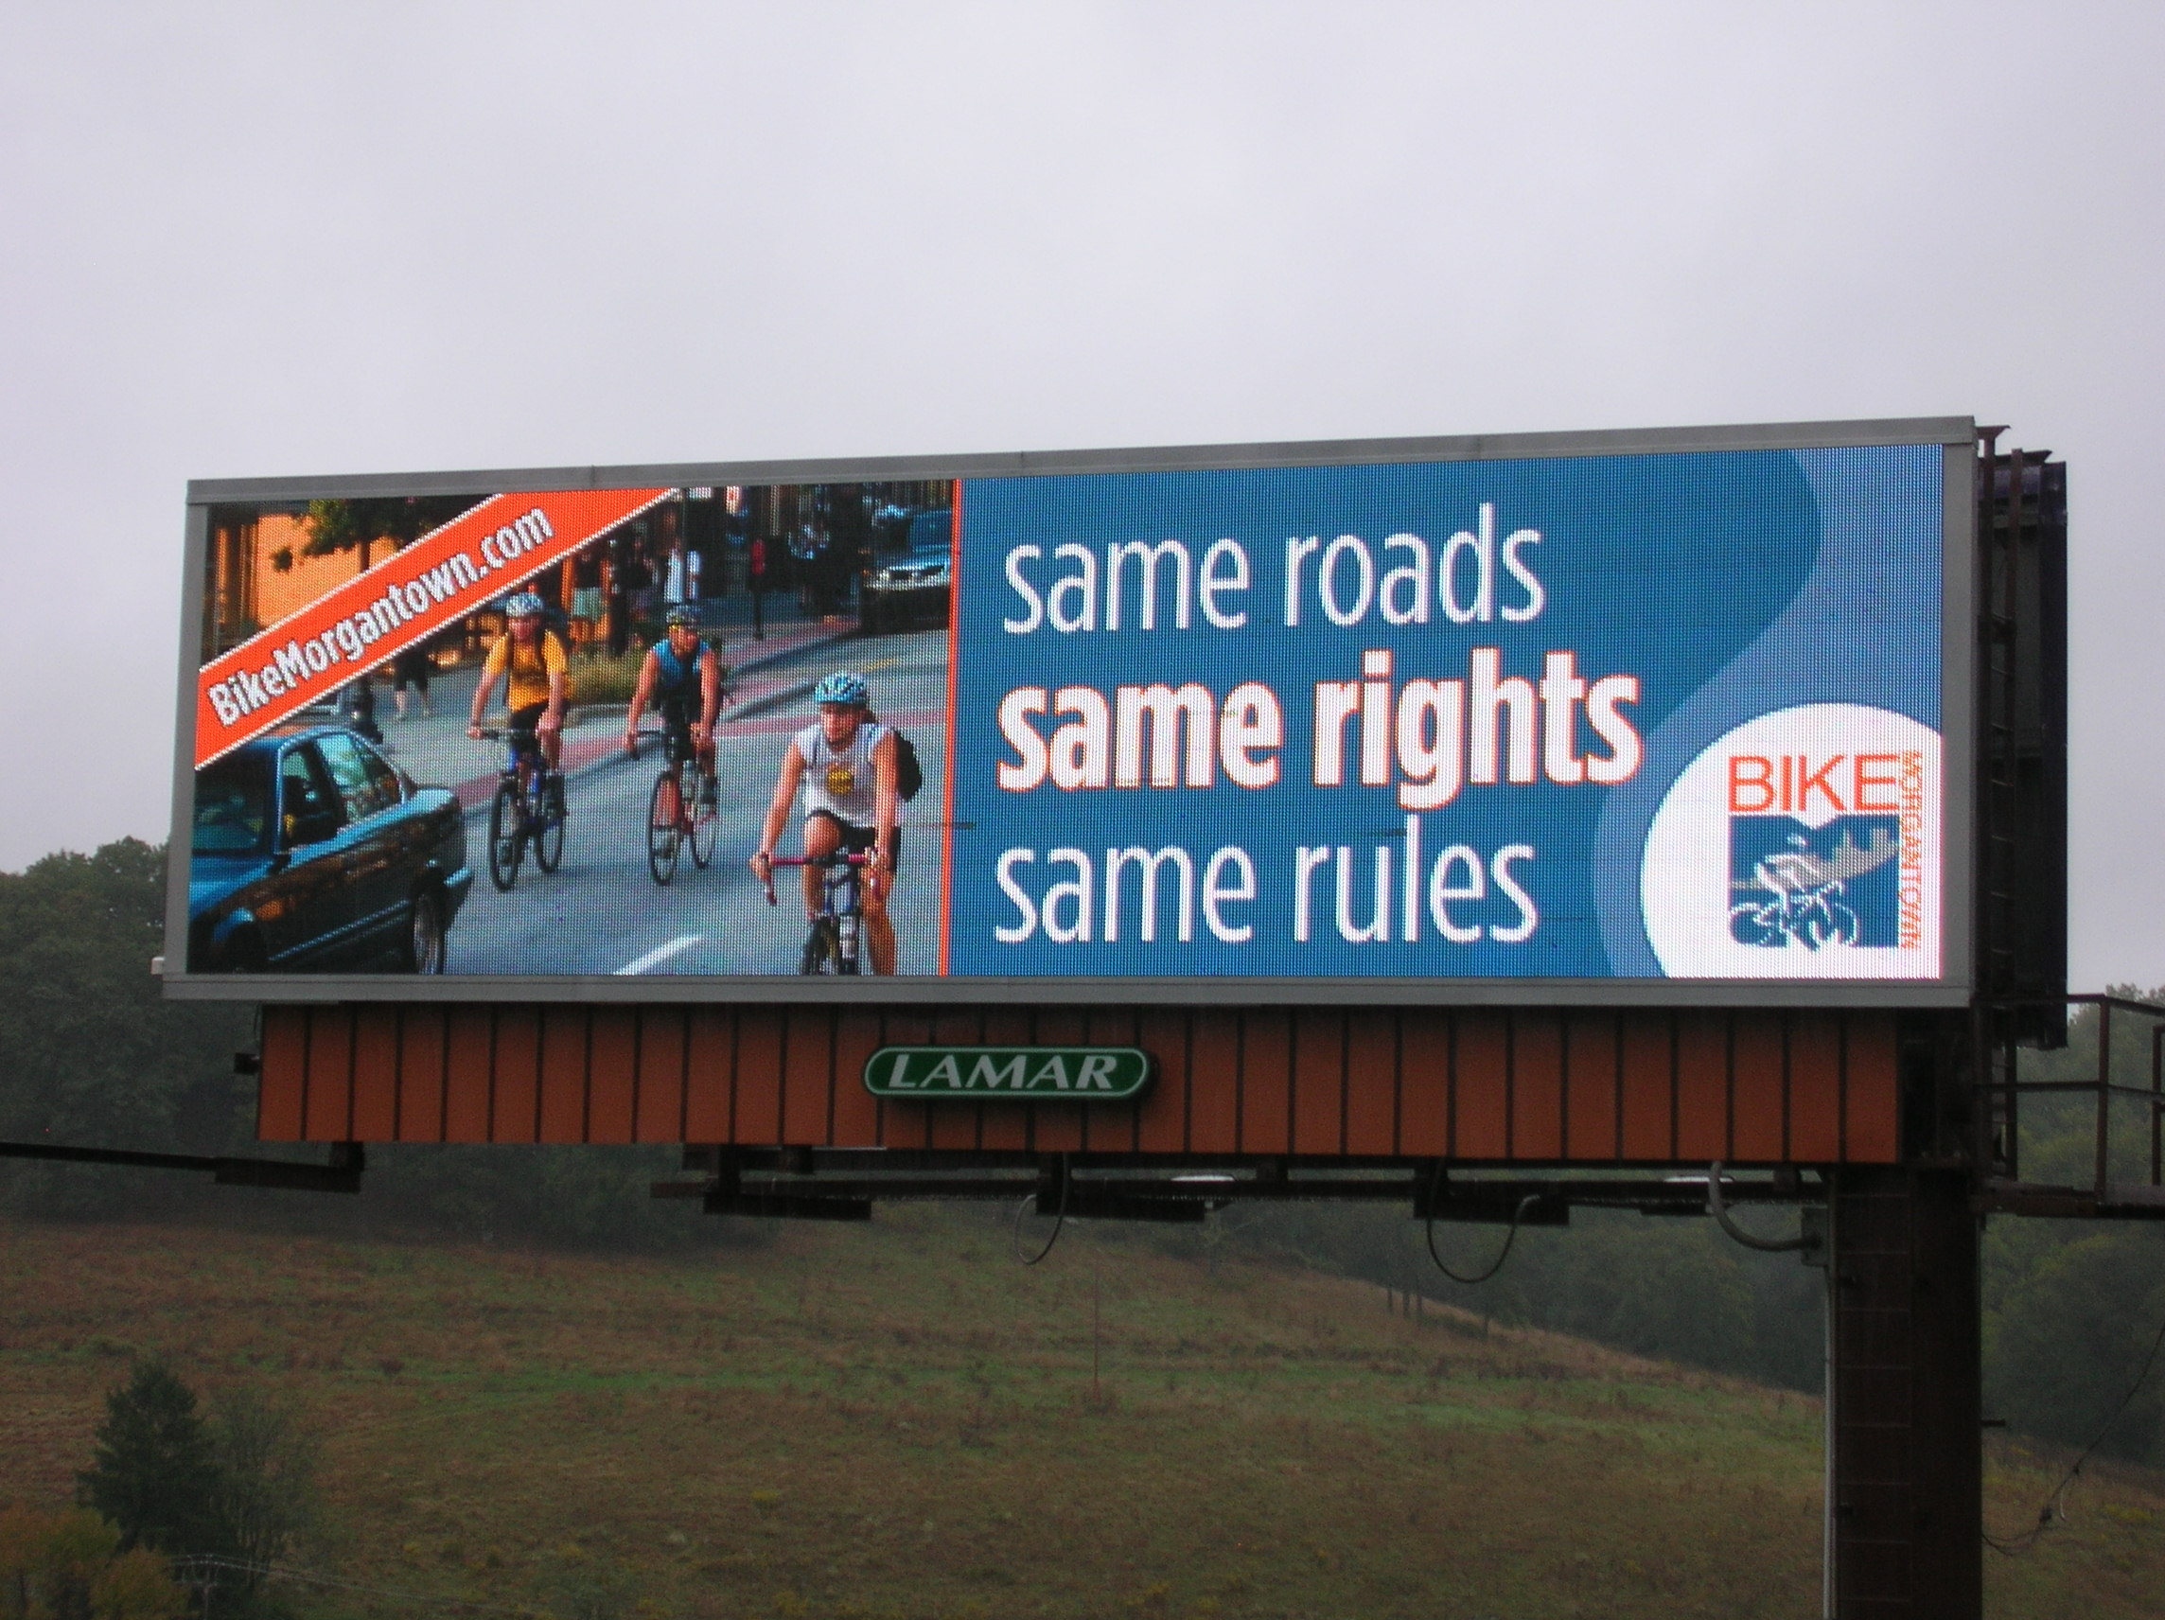

**Cool, huh?!**

Six other messages will be developed in the coming months. Following are the messages that will be on the billboards:

•     4 Wheels, 2 Wheels, 1 Road: Let’s Roll Together

•      Drive Nice, Bike Nice

•     A Bicycle Friendly Morgantown is a (changing adjective) Community

Changing adjective: Healthier, Greener, Smarter

* For Confident City Cycling

CLICK

(downward pointing arrow)

[BikeMorgantown.com](http://www.BikeMorgantown.com/)

# WVU Info Kiosks

We’re still working on getting the Same Roads, Same Rights, Same Rules billboard produced in the correct aspect ration to enable WVU to display it on their info kiosks located at PRT stations and in high pedestrian traffic campus buildings such as the Mountainlair.

# Bumper Stickers

Thanks to Aira, we have 1,000 bumper stickers and now we need a distribution plan. Frank asked for your ideas or feedback on the following proposal, giving:

1. a few to each of you at next Thursday's BB meeting;
2. a few to each Traffic Commission member at next Wednesday's TC meeting;
3. a hundred or so to Pathfinder and Wamsley Cycles;
4. fifty or so to the Greater Morgantown Commerce and Visitor's Bureau.

Jim liked 1-4. Ryan (who is not a BB member but should be) suggested giving them to participants at upcoming races. Derek suggested that we post their availability on BikeMorgantown.com and monbikeclub google group.

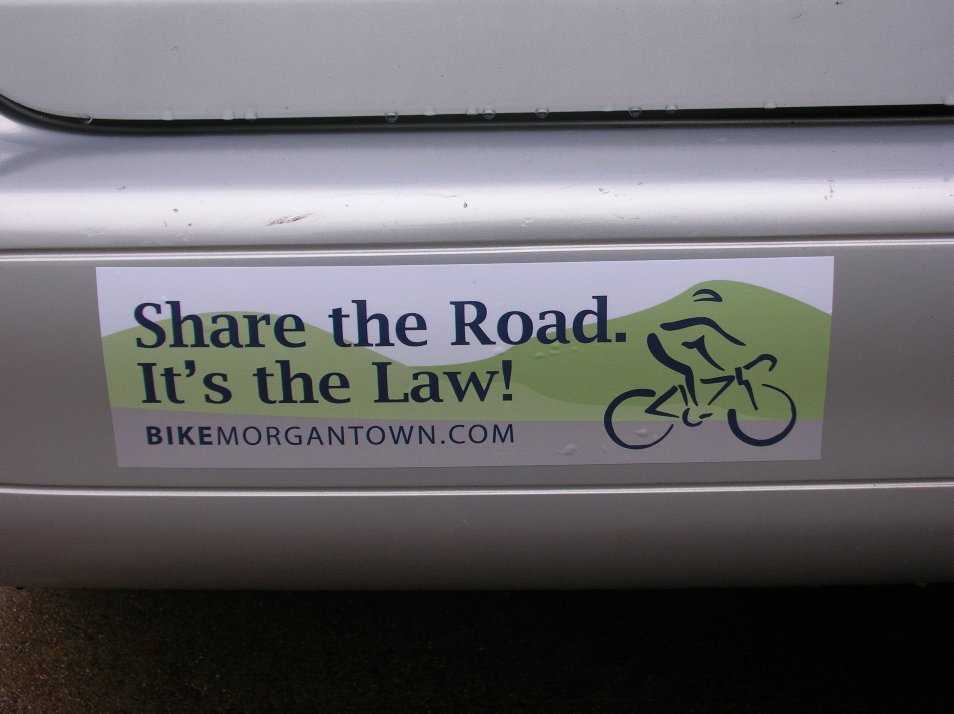

**Thanks, Aira!**

# Bicycle Route Map / Signage Plan

Derek’s working on combining the Bike Route map with the map that we produced to show the locations of the Shared Lane Markings and the Bicycles May Use Full Lane signs. He will replace the SLMs and BMUFL signs with Share the Road signs. On the Bike Route, we’ll identify locations for Bike Route signs. As usual, Derek’s handling this single-handed besides balancing a new baby, a job, cycling and playing guitar so he could use some help.

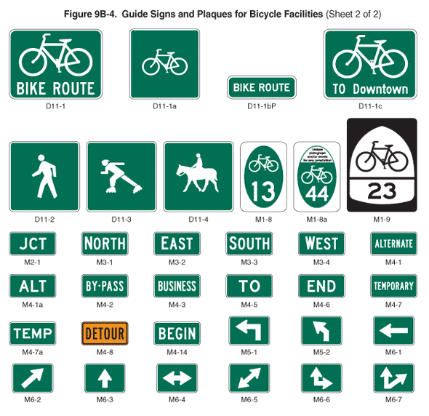

**Bike Route** and other irrelevant signs that I couldn’t figure out how to delete

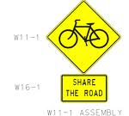



**Shared Lane Marking**

