Morgantown-Area 2018 TAP Grant Options
Current Steering Committee:
- Traci Knabenshue, WVU, Director of Sustainability – Traci.Knabenshue@mail.wvu.edu
- Vaike Haas, WVU, Assistant Professor of Landscape Architecture – vaike.haas@mail.wvu.edu
- Ella Belling, Mon River Trails Conservancy, Executive Director – ella@montrails.org
- Andrew Stacy, City of Morgantown, Communications Manager – astacy@morgantownwv.gov
- Alex Stockdale, City of Morgantown, Assistant City Engineer – astockdale@morgantownwv.gov
- John Whitmore, City of Morgantown, Planner III – jwhitmore@morgantownwv.gov
- Frank Gmeindl, City of Morgantown, Bicycle Board, Member – fgmeindl@gmail.com
- Drew Gatlin, City of Morgantown, Bicycle Board, Chair – johngatlin@gmail.com
- Matthew Cross, City of Morgantown, Pedestrian Safety Board, Chair – crossnyc@hotmail.com
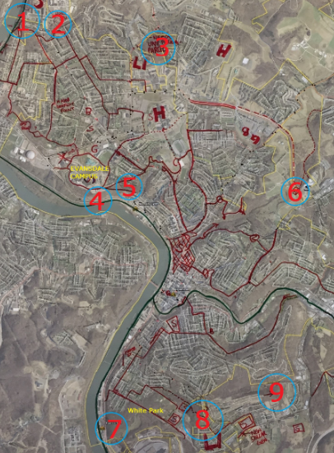
- Rick Landenberger, WVU, Assistant Professor of Geography (Also affiliated w/ WV Land Trust) – rick@wvlandtrust.org
Potential Project Locations:
1. *Timberline Apartments / Capri Lane / Suncrest Elem. - Rail Trail Connector Trails
2. *Eastern Avenue / Flagel Street Connector
3. *University parcel / Van Voorhis Trail
4. Upper Arboretum Trail
5. *Campus Connector
6. Falling Run / 705 Shared-Use Path / Eastwood Elementary Tunnel
7. *White Park - Rail Trail Connector
8. *Eastern White Park / New Dollar General / South Middle / MTEC / Mountain View Connector
9. East Oak Grove Cemetery / Greenbag Rd Bypass
* Indicates project within (or mostly within) Morgantown Municipal Limits
- Timberline Apartments / Capri Lane / Suncrest Elem. - Rail Trail Connector Trails
This proposal contains many sub-projects. We met 8-11am on 27 October to walk and flag these trails. Vaike Hass currently leads the project and developed a compelling document (attatched) outlining why neighborhood connectors are vital to the northern Suncrest neighborhood. Some considerations:
- MRTC already has an RTP-funded project in the vicinity (Collins Ferry Connector. Need to ensure that final proposals for these trails has either a complementary or a different set of motivations and benefactors, not conflicting. That project connects the trail to Collins Ferry Rd a little over a half mile further north of the elementary school.
- There are existing “desire paths” and informal trails all around these properties, particularly behind Suncrest Elementary. We will be formalizing some of them with these projects.
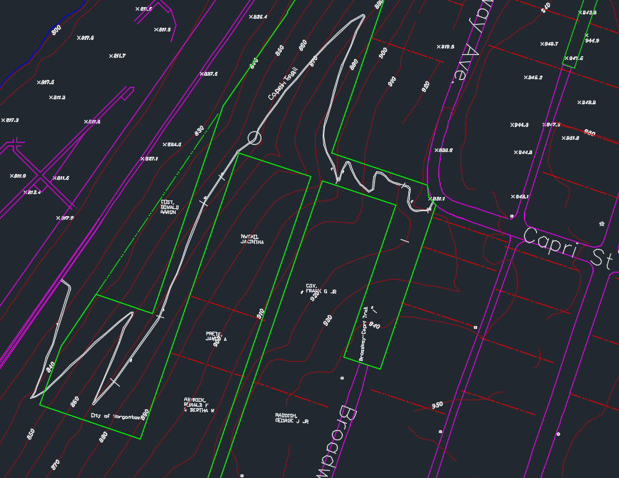
- Two of the proposed trails are already on municipally-owned properties (though these are likely MUB properties, which are slightly more complicated than paper street right-of-ways):
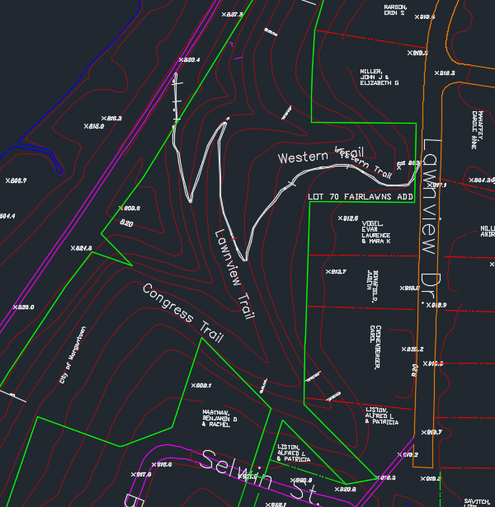
- A couple lie outside current city limits and / or on school board property:
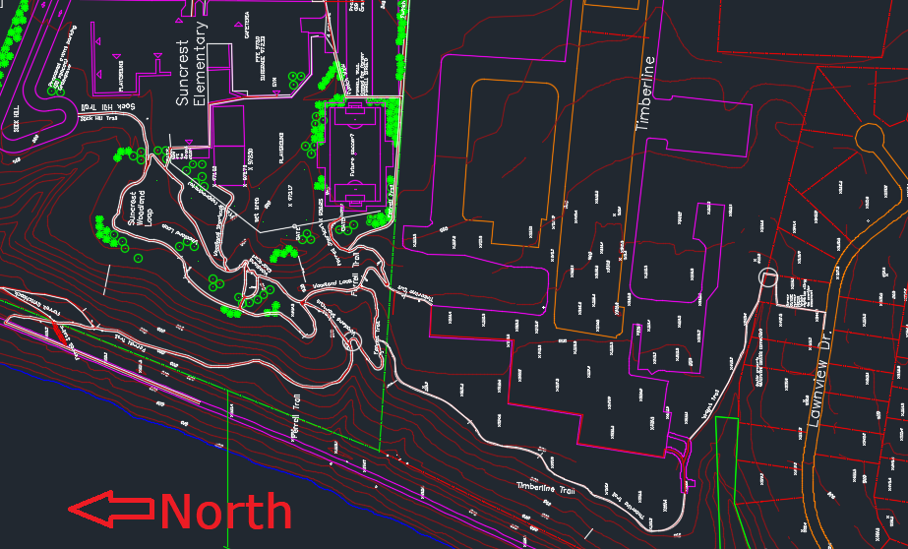
- Eastern Avenue / Flagel Street Connector
This project (outlined in red below) lies on city-owned right-of-way and would connect Eastern Avenue with Flagel, providing a direct extension to a well-used bike route. The trail would run just under 400’, and it would serve the area well by helping cyclists and pedestrians originating east of Collins Ferry Road with destinations to the north:
- Suncrest Elementary
- Mylan Pharmaceutical
- NETL
- Timberline Apartments
- Social Security Administration
- DOE Library
- WVU Safety & Health Extension
- Collins Ferry Rail Trail Connector
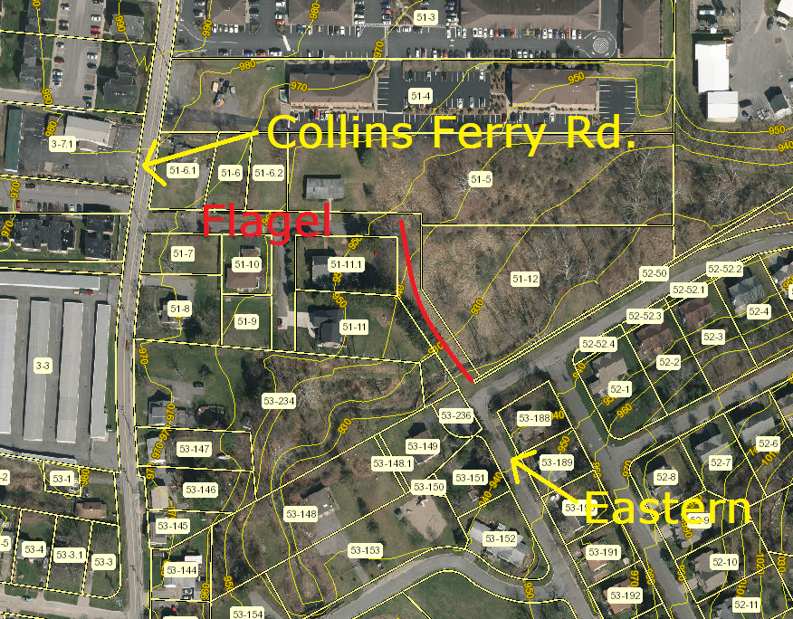

- University parcel / Van Voorhis Trail
This parcel is completely undeveloped and does not appear to contain any existing trails. A couple trails in the north and east sections of the parcels could be proposed, but no plan is yet developed (even in draft form). Such trails would serve as a good connector for North Elementary. It would also benefit cyclists and pedestrians originating from the other side of Van Voorhis with destinations immediately south (Mylan, WVU Health Sciences, etc).
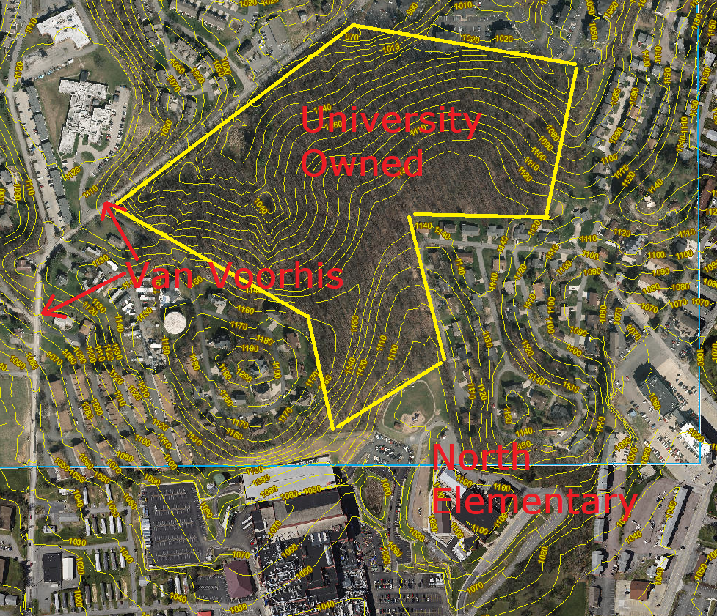

- Upper Arboretum Trail
Zach Fowler (director of the Core Arboretum and a professor of biology at WVU) leads this project and hopes to leverage the landscape architecture program in Spring 2018 to help design it. It follows an old road bed and would provide a roughly ¾ mile path to climb 209 feet (resulting in a 3-degree overall slope) versus the existing ¼ mile path up the service road (which has an overall slope of around 9 degrees and much steeper local sections). The path crosses parcels owned by the City of Morgantown, the DOH, and WVU.
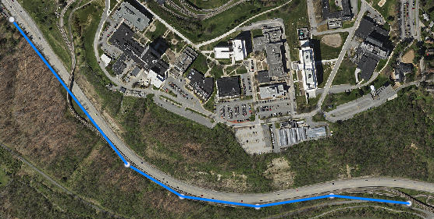

- Campus Connector
The nearby campus connector has long existed in both reality (as a very steep trail) and in proposals (as everything from a $500K gravel trail to a $2.5M ADA asphalt, lighted path). These proposals vary on their use of WVU and Saab Land Trust parcels. Details of those proposals can be found at http://osenergy.org/cc/ and in the recent study conducted by the MPO on University Avenue (bottom)
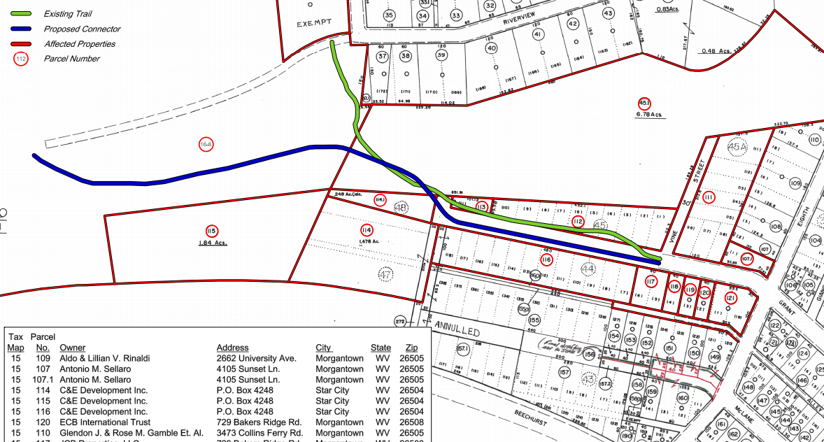
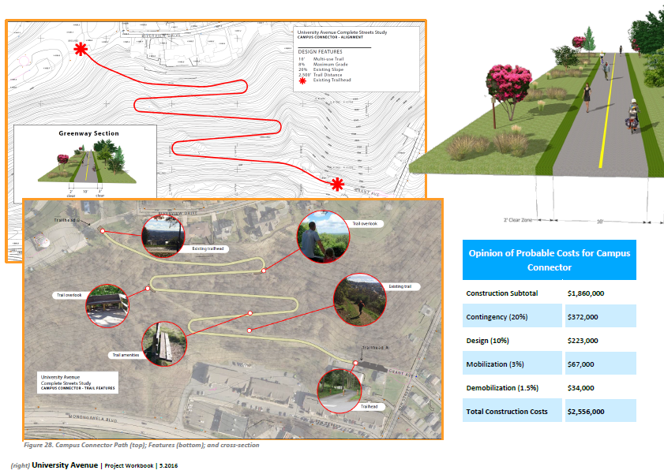
- Falling Run / 705 Shared-Use Path / Eastwood Elementary Tunnel
This project would re-open and improve a livestock tunnel originally provided to WVU when the DOH bisected their farm with 705. Students from Eastwood Elementary used the tunnel regularly in the past; it has recently been closed (unsure by whom, though). WVU property lies on both sides of the tunnel and DOH maintains 705. This stretch of 705 has reportedly been classified as a controlled-access highway, and its lack of bicycle and pedestrian-friendly facilities reflects this classification.
Our successful 2016 TAP grant established $500K to help design and build a shared-use path on the east / north east side of 705. That path will connect this area to WVU’s Health Sciences campus, and the recent Falling Run trails projects connect this area to WVU’s downtown campus. These connections are not, however, WVU-centric – they benefit a massive number of people with origins and destinations along major corridors. This tunnel would be the final connection between these two projects.
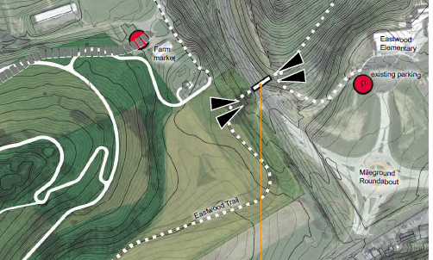
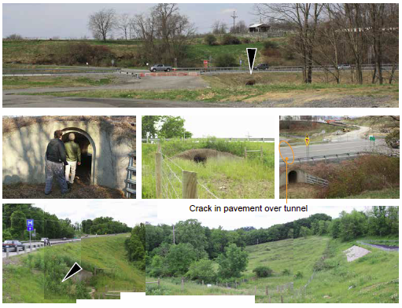
These photos are borrowed from the Falling Run Greenspace Master Plan (July 2016 version) by Vaike Hass.
- White Park - Rail Trail Connector
This project sits high on the MPO prioritized list of alternative transportation projects (similar to the campus connector) and has long existed in various proposals, listed below:
  - The City of Morgantown applied for a pedestrian-activated crosswalk at the traffic signal and an ADA ramp up to existing trails in White Park from that point. That ~$110K TAP application was submitted for FY2017 and was not granted.
  - Option 2 is a pedestrian bridge over Don Knotts
  - Option 3 is a path down from White Park, under the bridge that crosses Cobun Creek, and up to the existing trailhead next to Sargasso. This would impact MUB, Waterfront LLC, and DOH properties. See below for a diagram of this proposal (provided by Rick Landenberger, annotated by Drew Gatlin).
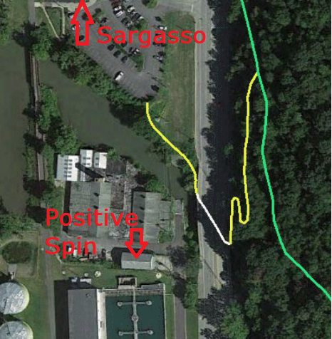

- Eastern White Park / New Dollar General / South Middle / MTEC / Mountain View Connector
This would formalize a few paper streets already in use by commuters (most notably by Christiaan Abildso’s Mountain View Elementary crew). It would improve access for three schools, and the project could also include improvements that would benefit the nearby low-income communities. A new dollar general store is planned for Lucky Lane, which lacks a sidewalk. The diagram below shows existing trails in green and right-of-way in red. LI stands for low-income.
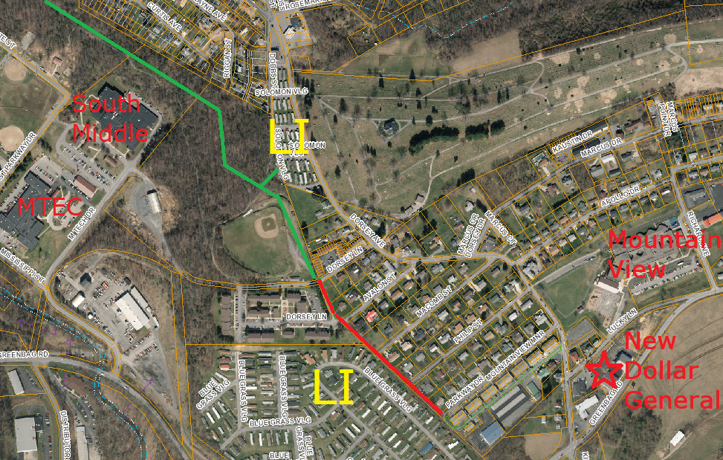
- East Oak Grove Cemetery / Greenbag Rd Connector
Few details are known about this project, and it falls outside current municipal limits. Although the general proposal has trails centered in Oak Grove Cemetery property, all proposals would likely dead-end without negotiation with a private landowner. This project would ultimately help to form a Greenbag road bypass for cyclists and pedestrians.

