Please support the Bike Bill (HB 4304 ) – Make Cycling Safer in West Virginia

Being a “cycling friendly” state would be a huge economic boom for West Virginia. There are studies by WVU, Duke University, and other entities that show the economic impacts of the bicycle industry, bicycle related tourism, economic value from tax review and hidden economic values are huge. However, West Virginia’s state code does not provide a safe environment for cycling and thus ranked close to the bottom by all the national cycling groups as a good place to cycle. We can change this by updating WV State Code by repealing the mandatory bike path language and the “far to the right” language and by adding a safe passage rule.

Why repeal Mandatory Side Path language -- WV is also only one of 11 states that have a mandatory side path requirement. A side path may be more dangerous than the road. Debris, collisions at egress and ingress points, and lack of continuity make it difficult for bicyclists commuting to work, school or for essential errands to stay on recreational bike paths.

Why repeal Far to the Right language – WV is only one of nine states that have far to the right requirements without exceptions. The current code makes it impossible for bicyclists to safely operate their bicycles as drivers as vehicles. The language puts cyclists in peril of:
- Motorists passing bicycles too closely;
- Motorists intruding into the adjacent lane when the adjacent lane is not clear;
- Right-turning vehicles crashing into cyclists;
- On-coming left-turning vehicles crashing into cyclists;
- Overtaking vehicles crashing into left-turning cyclists;
- Cyclists crashing into suddenly open doors of parked motor vehicles;
- Cyclists crashing because of objects; debris; pedestrians; animals and surface hazards that are more prevalent at the right edge of the roadway.

Why include a Three or Four Foot Passing rule -- Twenty three states have a minimum three-foot passing rule; Pennsylvania recently enacted a four-foot passing rule.
- creates an easily visualized distance for police to enforce and for motorists to employ when passing bicyclists;
- increases awareness that bicyclists are legitimate road users;
- establishes a bicyclist's right to space and improves interactions with motorists (previously, motorists may have been unsure of the minimum distance required to safely pass a bicyclist);
- can lead to an increase in the number and types of bicyclists within the community;
- may help support implementation of Complete Streets policies;
- is consistent with 3 or 4-foot passing requirements in adjoining states, PA, MD and TN motorists to employ when passing bicyclists.

For more information please contact Kasey Russell, WV Connecting Communities at 304.542.1994 or Gary Zuckett at 304.346.5891.
GRAPHICS:
Motorist passing bicycles too closely;
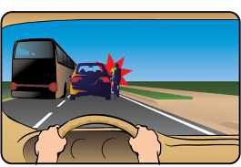

Right-turning vehicle crashing into cyclists (right hook)
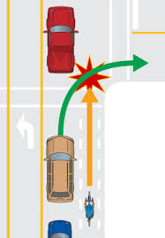

On-coming left-turning vehicle crashing into cyclists; (left cross)
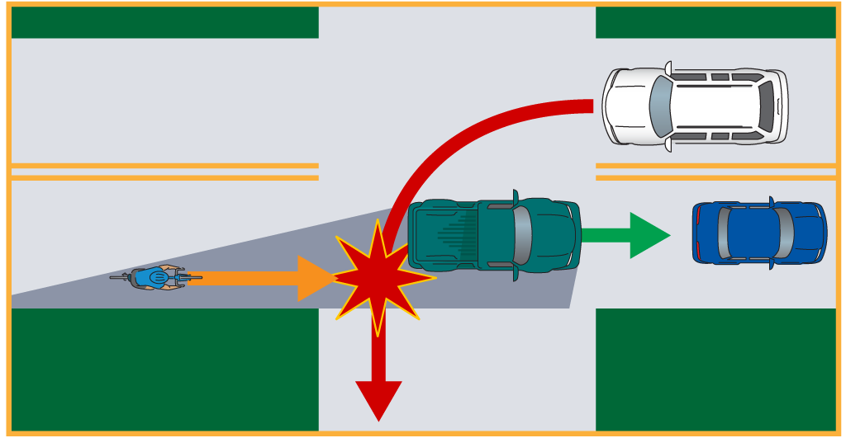

Cyclist crashing because of objects; debris; pedestrians; animals and surface hazards that are more prevalent at the right edge of the roadway.

