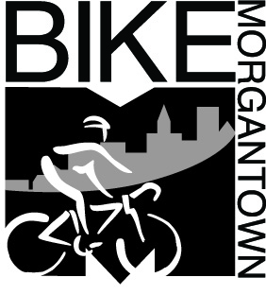
Frank D. Gmeindl
Chairman, Morgantown Municipal Bicycle Board
LCI #1703
491 Wilson Avenue
Morgantown, WV 26501

March 31, 2011

Fouad Shoukry, PE
Staff Traffic Engineer
West Virginia Department of Transportation
Division of Highways
1510 Grafton Road
Morgantown, WV 26508

Dear Fouad,

On behalf of the Morgantown Municipal Bicycle Board and Morgantown area cyclists, I would like to express our gratitude for the Share the Road signs that the WVDOH installed on South University Avenue. The size, number and locations of the signs is perfect for alerting motorists to the presence of bicyclists on that roadway as well as Morgantown roadways in general.

As you know, the City of Morgantown under a grant from the WVDOT has been conducting a campaign to educate bicyclists to operate their bicycles as vehicles on the roadway. Most cyclists prefer to drive their bicycles where there is no motor vehicle traffic. Morgantown has a few such facilities such as the rail trails but they only serve limited origins and destinations.

Some cyclists and some motorists are not aware that WV code grants cyclists the same rights to the road as motorists and subjects them to the same duties. The South University Avenue Share the Road signs reinforce that principle and hopefully will inspire bicyclists to act as drivers of vehicles and inspire motorists to treat them as such.

Sincerely,

Frank D. Gmeindl

cc:
Richard Warner, Section Head, WVDOT Planning Section
Cindy Cramer, Director, WVDOH Traffic Engineering Division
Bryan Radabaugh, WVDOH District 4 Design Engineer
Jeff Pifer, WVDOH District 4 Maintenance Engineer
Bill Byrne, Mayor, City of Morgantown
Roy Nutter, Chairman, Morgantown Traffic Commission
Terrence Moore, Morgantown City Manager
Jeff Mikorski, Morgantown Assistant City Manager
Terry Hough, Morgantown City Engineer
Damien Davis, Morgantown Assistant City Engineer

