Bicycle Board Participation

The Bicycle Board’s Procedural Guidelines direct us to work toward making Morgantown a Bicycle Friendly Community as defined by the League of American Bicyclists. Now, we all know that LAB has recognized Morgantown as a bronze level BFC. In my opinion, the Bicycle Board has accomplished the greatest task that it has been assigned.

For those of you that aren’t members of LAB and don’t pay much attention to the BFC program, attached is a map that shows BFCs and the BFCs in surrounding states.

You may also recall that our new City Manager, Terrence Moore set getting the bronze, his single bicycle-oriented objective.

The fact that Morgantown is the only BFC in WV, the lowest ranked state in the union, might also get WVDOT attention.

At this time, the Bicycle Board has more power than it has ever had and could very well have the most power that it will ever get.

City Council has unanimously adopted the Greater Morgantown Bicycle Plan so it is now their plan as well as ours. The MPO will factor the plan into the countywide long-range transportation plan.

The Bicycle Plan has 52 recommendations that we’ve developed over the years. Implementing those recommendations will require Bicycle Board participation.

When I sent out an e-mail asking you what you wanted to accomplish tonight, only one regular member, Ryan Post replied with suggestions.

Now, Ryan has moved and resigned but I for one will say that he made extraordinary contributions to the Bicycle Board during his membership and working “with” him energized me.

Several opportunities have come and disappeared because nobody replied when I asked for participation. Some Bicycle Board members have actually complained that I send too many e-mails.

To make the most of our LAB BFC recognition and to make something of Bike Month, we have much work to do that must be done quickly. I am very grateful to Traci and Derek for taking the lead in some on some of those tasks. I am also tremendously grateful to Jonathan for leading the grant writing effort. But, leading doesn’t mean doing all the work. Therefore, speaking of agendas, I suggest that the Bicycle Board devote its June meeting to raising Bike Board member participation.

With Ryan’s leaving, getting few or no responses to my e-mails and even getting complaints from members when I’m just trying to do my job, I’m feeling pretty unmotivated. As far as I know, I may be an obstacle to member participation so I’m planning to get out of the way for a while. I’m planning on missing the June meeting and possibly the July and August meetings but I’ll continue to read e-mails. Hopefully, you’ll figure out how to get more participation and you’ll still have a role for me in it but at this time, I’ll say, if you don’t, it’s OK with me.

Bicycle Friendly Communities in Surrounding States
(Bronze unless otherwise indicated)
Source: http://www.bikeleague.org/programs/bicyclefriendlyamerica/ (April 27, 2012)

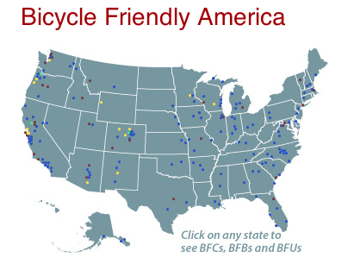

West Virginia (50th Bicycle Friendly State)
Morgantown

Pennsylvania (25th BFS)
Franklin
Philadelphia
Pittsburgh

Maryland (10th BFS)
Baltimore

Virginia (13th BFS)
Alexandria
Arlington (Silver)
Charlottesville
Harrisonville
Roanoke

Kentucky (33rd BFS)
Louisville
Lexington-Fayette County

Ohio (37th BFS)
Columbus
Dayton

