Bicycle Board: July 2017 General Meeting
Date: Thursday, July 6th, 2017 Time: 6:30pm-8:30pm Location: Public Safety Building, *Conference Room*
Clock Time | Duration (min.) | Topic | Discussion Leader | Desired Outcome
6:30 PM | 5 | Schmooze time | Everyone | All ready to start work
6:35 PM | 5 | Agenda | Drew | June minutes approved, July agenda finalized
6:40 PM | 10 | Open Action Items | Chip | Items reviewed, closed, and/or due date adjusted
6:50 PM | 20 | Ripe Bananas | Chip | Issues identified and plan to address them defined
7:10 PM | 10 | City-Funded Sharrows | Drew | Decision to fund painted sharrows with discretionary escrow
7:20 PM | 10 | Research Committee Check-In | Beth | Status update delivered regarding research efforts
7:30 PM | 15 | Member Recruitment | Drew | Plan to recruit members developed, ideal member defined
7:45 PM | 10 | New Action Items |  | List open items, responsible person, dates
7:55 PM | - | Meeting Adjourned | Drew

Read-aheads 1) June Minutes, Draft City Council Presentation
Notes:
Open Action Items are limited to 1 minute each and should follow the format below
- Item number was closed on date and requires follow up / new action item / ripe banana discussion OR…
- Item number remains open due to reason and requires follow up / new action item / ripe banana discussion and needs rescheduling to date
Potential Ripe Bananas (all ripe bananas are limited to 5-10 minutes, can include reports back from action items, and must make a request for future action)
- Parking rings / bike locker
- Paving updates
- 4th of July Parade debrief
- New council!

Open Action Items
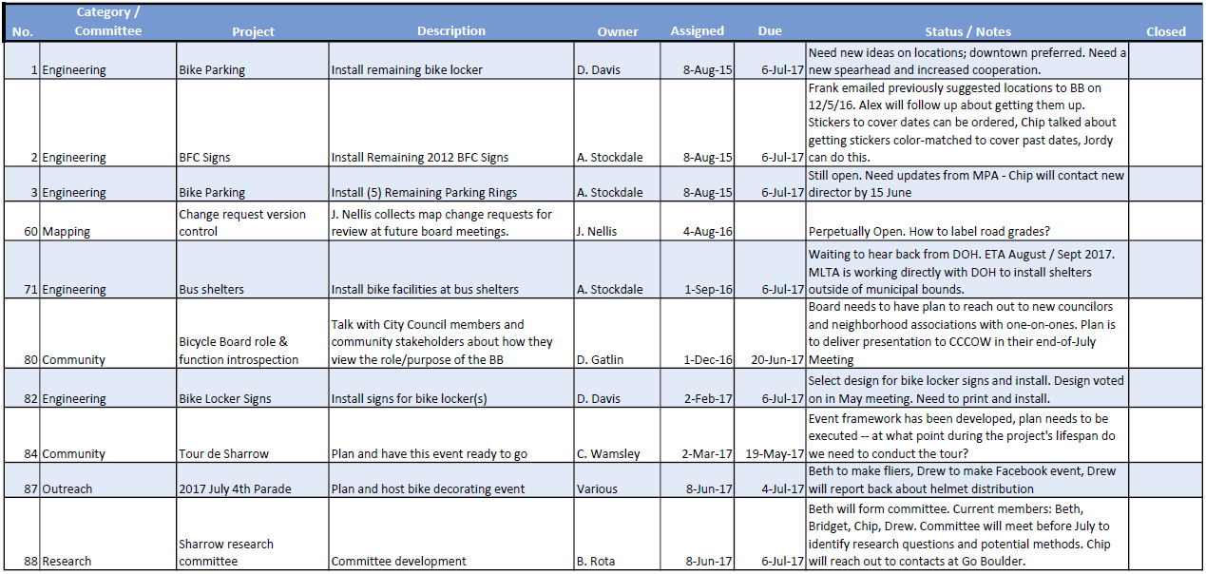
In attendance: Drew Gatlin, Chip Wamsley, Jonathan Nellis, Marilyn Newcome, Jonathan Rosenbaum, Frank Gmeindl, Jenny Selin, with new city councilor assigned to the bike board, Barry Wendell.
- Agenda
  - Meeting called to order by D. Gatlin at 6:35PM. There were no official changes to the last meeting’s minutes or this meeting’s agenda. H. Grandon moved to approve, M. Newcome seconded. Motion carried.
- Open Action Items
  - Items closed
    - #87, July 4th Bike Parade – Event completed, great attendance! Need to do follow-up/evaluation. Maybe look at different starting location (Mountainlair?)
      - MOTION – To offer greater assistance to Celebration of America regarding future bike processions. C. Wamsley moved, H. Grandon seconded. Motion carried.
    - #88, Sharrow Research Committee – Committee was formed and met June 22, see later in minutes for preliminary results of committee efforts
  - Items remaining open
    - #1, Bike Parking and #3 Parking Rings – Chip will reach out to new parking authority director Dana McKenzie. Many thanks to Tom Arnold for his 18 years of service on the MPA!
    - #2, BFC Signs – D. Gatlin to work with C. Wamsely on color match
    - #60, Mapping Change Request Version Control – Still looking for a solution to the grading problem. Still looking into LaneSpotter
    - #71, Bus Shelters – information from C. Wamsley that all projects are bike-related TIP projects are delayed until 2018, including the 2014 Sharrows / Shelters TAP grant. D. Gatlin received contradictory information from A. Stockdale, will report back next month.
    - #80, Bike Board role and expectations – Presentation delayed, will likely not be delivered in July
    - #82, Bike Locker Signs – D. Davis / A. Stockdale still need to update design based on May feedback
    - #84, Tour de Sharrow – Mentioned that we have a casual ride schedule, maybe tie together. There was concern expressed about the rock slide are on Mon Boulevard. Look into the marathon route
- Ripe Bananas
  - Try This! Minigrant program was awarded to West Virginia Connecting Communities to host helmet giveaways in conjunction with bike rodeos around the state. D. Gatlin suggested that board host a rodeo on September 23rd, the day before the Bike Summit. Board suggested the following for a curriculum:
    - Importance of cycling with a helmet
    - Riding skills
    - Knowledge about road responsibilities (laws) also geared towards adults
    - Pre/post test to begin evaluations
  - J. Rosenbaum and J. Nellis updated board on Positive Spin. They plan to roll out their new location at the end of July. The location is in the old Dinsmore Tire Shop by the water plant on the rail-trail.
  - There was discussion about the opportunity for development with the scheduled work at Krepps Park. We talked about an upgrade of pavement vs. gravel.
  - The Pedestrian Safety Board meeting is scheduled for July 10, and Fred Shoukry is reported to have plans to attend that meeting. D. Gatlin will invite Mr. Shoukry to meet with bike board members before or after that meeting regarding our grants.
- City-Funded Sharrows
  - Discussion centered around the Sharrows program. Items included: how much does each sharrow cost? Do we want to use paint or reflective material? How do we prioritize? F. Gmeindl said it will at the earliest August before things get done.
- Research Committee Check-In
  - The Sharrow research Committee met and looked at the information from Boulder, CO plan. It was suggested to share that information with the Board. C. Wamsley said there is no mechanism in place for productive measures.
- Member Recruitment
  - D. Gatlin updated the Board over position vacancies/removals due to attendance and relocation issues. Board is down to 10 members with availability in the following wards/areas; South Park, 7th ward, Evansdale, Woodburn, Wiles Hill, North Hills/West Run and South Hills/West Sabraton. Also in need of representatives for K-12/Youth and from WVU.
  - D. Gatlin also expressed a desire to create a Bike Board “white paper” highlighting FAQ for distribution to prospective members and/or prospective partners
New Action items (note, no new action items came with new due dates)
- J. Selin to investigate date for Celebration of America debriefing meeting, will invite board
- F. Gmeidl will deliver a Sharrow plan to the board regarding Willowdale, Jones, Charles, White, Stewart, Diamond/Carnegie, and North Spruce streets
- J. Selin will ask the WVU School of Journalism about intern placement for board strategic communication
- All board members are to come up with two items to include in the “white paper” that either
  - They would have appreciated knowing before they joined the bike board, or
  - They believe others should know about the bike board
- D. Gatlin will share Krepps park development proposal with board as available
- J. Selin will invite D. Gatlin to the next regional, chamber transportation meeting to increase chances of understanding opaque project delays.
- D. Gatlin will work on the color match for the BFC signs so they can be printed and installed.
With time running short, the meeting adjourned at 838PM.

