TO: Morgantown Traffic Commission

FROM: Morgantown Municipal Bicycle Board

SUBJECT: In-line Drainage Grates

DATE: August 4, 2010

The Morgantown Municipal Bicycle Board requests the Traffic Commission to take action to replace in-line drainage grates with grates that do not trap bicycle wheels.

Such in-line grates exist in several locations around Morgantown including Monongahela Blvd., Evansdale Drive and the passageway from Towers to the Recreation Center.

These grates may be under the control of MUB. On May 27, 2010, the Chairman of the Bicycle Board sent an e-mail message to Scott Copen of MUB requesting that the grates be replaced. He received no reply. On June 27, 2010, the Chairman of the Bicycle Board sent another message to Copen with copy to Tim Ball. Again, he received no reply.

On May 26, 2010, a bicyclist flew over the handlebars and landed on his face and shoulder when an in-line grate on Monongahela Blvd. in front of the Coliseum trapped his front wheel. While his injuries were minor, he could have broken his neck and even died.

Such in-line grates are also present on the Walnut St. bridge and the Westover Bridge. On November 8, 2009, the Chairman of the Bicycle Board submitted a service request through the City’s website to have these grates replaced. The city referred the Chairman to Kathy Westbrook at the WVDOH. ON November 17, 2009, the Chairman sent a message to Ms. Westbrook requesting the disposition of his request. Ms. Westbrook replied that she sent your request to our Bridge Engineer for his opinion and promised to inform the Bicycle Board Chairman of their plans. No follow up was received.

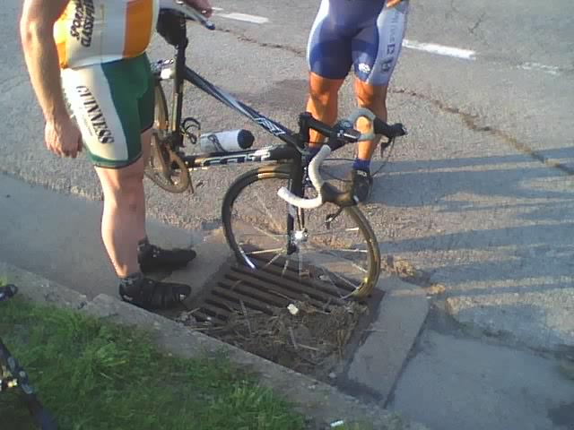

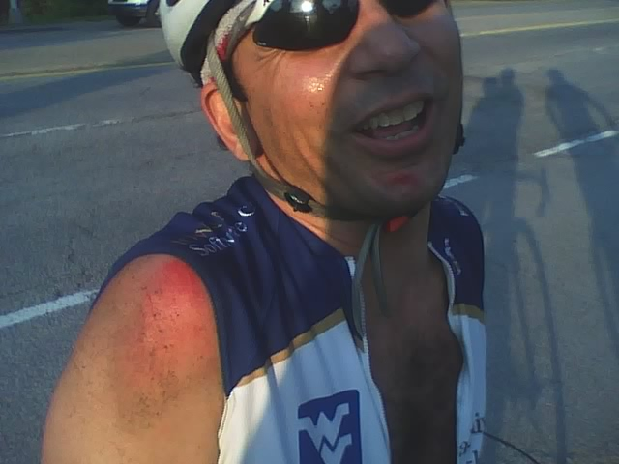

Correspondence with MUB about Morgantown in-line grates

From: Frank Gmeindl <frank.gmeindl@comcast.net>
Date: June 27, 2010 4:59:10 PM EDT
To: scopen@mub.org
Cc: tball@mub.org, Damien Davis <ddavis@cityofmorgantown.org>, Ryan Post <rpostwvu@gmail.com>
Subject: Fwd: Unnecessary Road Hazards-Drainage Grates

Scott,

I'm sure you get floods of e-mail as well as floods of rainwater and sewage to deal with so I can understand not hearing for you for a while after I sent you the message below. ¬†Eventually, some cyclist is going to sustain a lot more damage than shown in the photos that I sent you with the message below. ¬†I'd like to at least know that there's a plan to replace those in-line grates. ¬†

Frank D. Gmeindl
Chairman, Morgantown Municipal Bicycle¬†Board
LCI #1703
491 WilsonAvenue
Morgantown, WV 26501
304-376-0446
Cyclists fare best when they act and are¬†treated as drivers of vehicles

Begin forwarded message:
From: Frank Gmeindl <frank.gmeindl@comcast.net>
Date: May 27, 2010 4:50:34 PM EDT
To: scopen@mub.org
Cc: Damien Davis <ddavis@cityofmorgantown.org>, Ryan Post <rpostwvu@gmail.com>
Subject: Fwd: Unnecessary Road Hazards-Drainage Grates

Scott,

Could you advise me on how to get Morgantown area in-line storm grates corrected so that bicycle tires don't fall into them? ¬†Below is a letter that I received from a cyclist. ¬†It includes some gruesome photos of a cyclist that rode into one of these grates and landed on his face and shoulder. ¬†His injuries could have been much worse, even fatal.

Frank D. Gmeindl
Chairman, Morgantown Municipal Bicycle¬†Board
LCI #1703
491 WilsonAvenue
Morgantown, WV 26501
304-376-0446
Cyclists fare best when they act and are¬†treated as drivers of vehicles

Begin forwarded message:
From: "Ryan Post" <rpostwvu@gmail.com>
Date: May 26, 2010 8:47:03 PM EDT
To: "'Frank Gmeindl'" <frank.gmeindl@comcast.net>, "'Gunnar Shogren'" <gshogren@gmail.com>
Subject: Unnecessary Road Hazards-Drainage Grates

How do you feel about this email?¬† Also, who should I send it to?
¬†
¬†
I would like to point out a hazard and liability that unnecessarily exists on the roads, only because maintenance workers are unaware.
¬†
There are older style square drainage grates on many shoulders of the roads which have been installed with the grooves running parallel to traffic.¬† These grooves pose a serious hazard to bicycle tires which can slip into them causing the rider to be flipped with accelerated speed into the ground* most likely causing injury to the rider, as well as the bike. In addition, the sudden stop poses an issue to following cars who may then have to avoid whatever pile of man in machine is now laying in the roadway.
¬†
This occurred today, in on Mon Blvd in front of the coliseum by an experienced cyclist who did not see the grate as it was covered with debris.¬† Image1 shows how the hazard exists, and Image2 shows the injuries sustained. These injuries were quite minor as he knew how to position his body to minimize impact on his face. The bicycle also received damage, exceeding $200.
¬†
The simple fix is to rotate the grates so the grooves are perpendicular to travel direction.
¬†
After the incident, I noticed every grate along Evansdale Drive from the CAC to Towers was hazardously installed.
¬†
Ryan Post
¬†
*If you consider the physics of it, a bike traveling at 15mph (which is actually a slow speed-equivalent to falling from 7.5‚Äô), will have 100% of that travel velocity converted into downward velocity as the bike pivots on the stuck front wheel, in addition to the speed grained by falling from a standard riding height of about 5‚Äô. The impact will be directly onto the front of the cyclist, involving the face, and possibly breaking bones in the arms, wrists, hands, shoulders, and collarbones, as well as a possible concussion.
¬†
Images are attached, but can also be found at:
http://dl.dropbox.com/u/463685/Image1.jpg
http://dl.dropbox.com/u/463685/Image2.jpg
¬†

Correspondence with City and WVDOH on Walnut St. and Westover Bridge grates

On 11/18/2009 12:27 PM, Westbrook, Katherine S wrote:
Dear Mr. Gmeindl,
I have sent your request to our Bridge Engineer for his opinion. As
soon as I hear back from him we can schedule necessary work to be
performed on the grates. I will also inform you of our plans as soon as
they can be made. Thank you for taking the time to bring this matter to
our attention.

Thank you,
Kathy Westbrook
Monongalia Co. Hwy. Adm.
WVDOH
1510 Grafton Road
Morgantown, WV 26508
(304) 285-3209
Katherine.S.Westbrook@wv.gov

-----Original Message-----
From: Frank Gmeindl [mailto:fgmeindl@verizon.net]
Sent: Tuesday, November 17, 2009 11:17 AM
To: Westbrook, Katherine S
Cc: ecumpsten@cityofmorgantown.org; Terry Hough
Subject: Re: Request Partner Email

Ms. Westbrook,

Can you tell me the disposition of Request ID 24648 that I submitted to
the City of Morgantown. It was to repair a drain grate on the Westover
bridge. The first grate going from Morgantown to Westover can trap a
bicycle wheel and cause bicyclists to fall and get run over by a motor
vehicle. When the Westover bridge was built, the drainage grates were
slotted in the direction of traffic flow, as they still are on the
Walnut Street bridge. On the Westover bridge, cross pieces were welded
into the grates to make them safe for bicycles to cross. Some of those
cross pieces have fallen out making the grate dangerous. I also
submitted Request ID 24649 about the grates on the Walnut Street bridge.

I received the message below that stated my request 24648 has "been
marked Completed" but the problem still exists. Can you tell me what to

expect with the grate on the Westover bridge and the grates on the
Walnut Street bridge?

Many cyclists use both the Walnut Street and Westover bridges. I
appreciate your efforts to maintain those bridges safe for them.

Frank Gmeindl
491 Wilson Ave.
304-284-8094

On 11/9/2009 8:26 AM, DO-NOT-REPLY@govtsystems.com wrote:

Hello Frank Gmeindl,

This email is to notify you Request ID 24648 submitted on Sunday,

November 08, 2009 3:20 PM has been marked Completed as of Monday,
November 09, 2009

Please take a few moments to fill out a survey providing feedback on

your experience using our system at: http://www.morgantown.com/

*****************************************************************
Request Form Name: Street Maintenance
Request Form Description: Use this form to request maintenance or

repair of City streets.

Request was successfully submitted. by Citizen on 11/8/2009 at 3:20 PM

*****************************************************************

This e-mail is for your information only. Please do not use e-mail to
respond directly to this message.

Regards,
Morgantown

Subject: Request Partner Email From: <DO-NOT-REPLY@govtsystems.com>
Date: Mon, 09 Nov 2009 07:20:49 -0600 To: "fgmeindl@verizon.net"
<fgmeindl@verizon.net> Monday, November 09, 2009 Frank Gmeindl
Morgantown WV 26501 Dear Frank, This letter is to provide you an
update on a request to the Morgantown, received on Sunday, November
08, 2009. REQUEST SUMMARY All of the concerns listed in requests
numbered 24647-24649 are areas that are the responsibility of the
State Department of Highways. These areas of concern will be passed
on to them. The City has no jurisdiction in nthese areas. Any
additional requests in these area should be directed to Cathy
Westbrook at DOH 285-3209. Thank you. Contact Details From: Frank
Gmeindl Email: fgmeindl@verizon.net Telephone: 304-284-8094 Language
Preference: Address 1: 491 Wilson Av. Address 2: City: Morgantown
State: WV Zip Code: 26501 Pref. Method of Response: E-Mail Question
and Responses What type of repair or maintenance are you requesting?:

other (plese describe below) If other, please describe. : Replace
drainage grates so a bicycle can drive over them without falling
through. Use this space to give the City additional information about

the location or nature of your request. : The drainage grates on the
Walnut Street bridge have slots that can catch a bicycle wheel and
cause a bicyclist to fall and get run over by a motor vehicle.
Replace with grates that bicycles can drive over without falling
through. Please provide more information about the request location
(nearest business, landmarks, or development).: Walnut Street Bridge
REQUEST DETAIL Your request has been assigned to Erin Cumpston. The
status is Active with a priority of Normal. If you have further
questions about this issue, please contact us. Sincerely, Erin
Cumpston Public Works Department

