Dear walking and/or cycling enthusiast:

WV Connecting Communities invites you to attend our fall membership meeting in Fayetteville at Adventures On The Gorge on October 23, 2015 at 3:30 pm and immediately afterwards join us for a reception/dinner ($30.00 cover) hosted by the New River Trail Alliance and Active Southern WV. Exciting projects are taking place with walking and cycling in West Virginia, please join us to learn more and find out how you can help.

The New River Gorge Trail Alliance, an organization that will promote a regional trail system to connect gateway communities of the New River Gorge Region with each other and the National and State Parks. NRGTA will cover the 5 county region surrounding the New River Gorge (Fayette, Nicholas, Raleigh, Greenbrier and Summers Counties).

WVCC is a statewide nonprofit dedicated to creating an environment where people can walk and cycle to work, school, to run errands or for recreation/fitness. WVCC was formed in 2013 and has already succeeded in getting legislation passed requiring that motorists give cyclists three feet clearance when passing and enhanced language for riding on the roads of WV.

Agenda for the event:
Friday Oct 23:
3:30 p WVCC board meeting
5:00 p Reception (cash bar), Introductions by Bill Wells
6:15 p Dinner, Presentations by Bill Wells, Gary Morefield and Melanie Seiler with the NRGTA highlighting the current local projects and next steps
Saturday Oct 24:
9:00 a Walk and Bike ride

The deadline to mail in your check for $30 and save your space is October 16th. Please make checks payable to WVCC, PO Box 973, Charleston, WV 25324.

We hope you can attend this exciting event that will help transform this area into a bicycling destination.

If you have any questions or comments, please contact:

Kasey Russell Bill Wells
304.542.1994 304.610.8293
Russell.kasey@gmail.com bwells7027@gmail.com

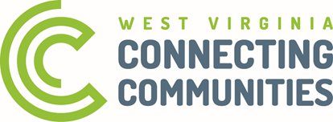

PO Box 973 Charleston WV 25324 www.activeswv.com
wvconnectingcommunities.com

