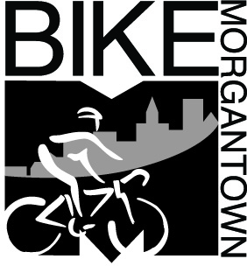 | Brian Ricketts  Morgantown Municipal Bicycle Board  491 Wilson Avenue  Morgantown, WV 26501  304-554-9450  Your e-mail address
May 6, 2016
Re: Morgantown Bike Month, May 2016

Dear Sir or Madam:
My mane is Brian Ricketts and I am a member of the Morgantown Bicycle Board. The month of May has been designated by the city as Morgantown Bike Month and to celebrate, we will be hosting a number of events. We are looking for organizations who would like to partner with us in promoting the events. The following events will be happening during the month.

- Bike to School Day, May 4th

- Bike to Work Day, May 20th

- Bike Rodeo, May 22nd (for kids to learn bike skills)

By promoting these events, you will be helping:
- Educate kids and adults about cycling in our community
- Helping give back to the Morgantown Community and supporting events that encourage people to live healthier and more actives lives

We are asking specifically for you to promote the events by:
- Hanging posters in your facility
- Sharing posters on any social media sites
- Mentioning the events in staff meetings, daily news to the school, and encouraging your staff to share with their students’ parents
- Or any other means for which you disseminate information

Please, won’t you consider helping us promote these events today. Please contact me at ricketts34wafa@gmail.com or call 804-241-8116 for more information.

Sincerely,
Brian Ricketts
Lead, Bike Month Committee
Morgantown Bike Month

Morgantown Bike Board
As a committee of the Traffic Commission, the purpose of the Bicycle board is to work to make Morgantown a Bicycle Friendly community as defined by the League of American Bicyclist so as to reduce traffic demands, afford better air quality, and improve public health. It is the Vision of the Bicycle Board that “All Morgantown residents can enjoy bicycling safely and fearlessly anywhere, anytime, and for any reason.

