ordinance nO. _______________
AN ORDINANCE AMENDING SECTION 1365.04 OF THE CITY OF MORGANTOWN PLANNING AND ZONING CODE AS IT RELATES TO BICYCLE RACK REQUIREMENTS.
WHEREAS, the Morgantown Bicycle Board’s 2012 Greater Morgantown Bicycle Plan, the City of Morgantown’s 2013 Comprehensive Plan Update, and the Morgantown-Monongalia Metropolitan Planning Organization’s 2040 Long Range Transportation Plan encourage the expanded use of the bicycles as a mode of transportation, necessitating increased infrastructure to include bicycle storage; and,
WHEREAS, bicycle storage standards are not unique to the City of Morgantown and are utilized throughout the Unites States to encourage and facilitate bicycle use; and,
WHEREAS, bicycle storage standards were established with the goal of providing flexibility for developers to deliver bicycle storage amenities at a level that is of minimal disturbance.
NOW, THEREFORE, the City of Morgantown hereby ordains that Section 1365.04 of the City’s Planning and Zoning Code is amended as follows (deleted matter struck through; new matter underlined and bolded):
(Q) Bicycle Storage – Long-term bicycle storage and short-term bicycle storage shall be provided in all Developments of Significant Impact.
(3) Bicycle Rack Requirements. Long-term and short-term bicycle storage spaces using bicycle rack facilities shall observe the following design standards:
  - Each bicycle storage space shall provide a minimum dimension of three (3) feet in width by six (6) feet in length by four (4) feet in height. Bicycle storage spaces may overlap one another to allow for instances where two or more bicycles can be secured to a bicycle rack. Overlapped storage spaces shall provide access to each individual bicycle in a manner that has the effect of promoting the bicycle storage spaces spatial dimension requirement, for each individual bicycle, as show in the image below.
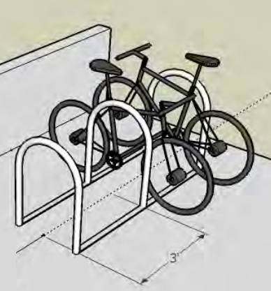
  - Bicycle storage areas shall should include a minimum of three (3) feet of clearance around racks or lockers to give cyclists room to maneuver and to prevent conflicts with pedestrians or parked automobiles.
  - Adequate lighting (no less than 2.0 footcandles) must be provided for a bicycle storage area and the route from the storage area to the nearest building entrance intended for the cyclist.
  - Racks shall conform to Americans with Disabilities Act (ADA) standards for protrusions in the right-of-way including the ability to detect the rack with a white cane. To be detected by a white cane the protruding or leading edge of the rack shall be 27" or less above the sidewalk surface. Between 27" and 80" above the sidewalk surface, protruding or leading edges may overhang a maximum of 12".
  - The top of the bicycle rack design shall be a minimum of 36 inches tall. Except for the bicycle rack supporting brackets, the shortest section of the bicycle rack must be a minimum of 27 inches tall to be perceived by pedestrians and avoid tripping hazards.
  - The space between rack features shall be larger than 9" and smaller than 3.5" to avoid children trapping their heads.
  - The design shall not include sharp edges.
  - Areas having more than one row of racks shall be separated by aisles. An aisle is measured from tip to tip of the bicycle storage spaces between racks. The minimum separation between aisles shall be a minimum of four (4) feet.
  - Racks near walls should be placed so the rack’s two (2) bicycle connection points are perpendicular to such wall. Racks placed near walls shall maintain a four (4) foot minimum separation between the edge of the bicycle storage space rack and the wall. Racks attached to walls shall provide adequate space to provide storage without the removal of bicycle components due to bicycle contact with the wall.
  - Racks placed near curbs should maintain a minimum separation between the edge of the bicycle storage space rack of four (4) feet.
  - Racks should have protective coatings designed to protect bicycle frames from scratching and damage.
  - Racks should be able to resist being cut or detached using common hand tools, such as bolt cutters, pipe cutters, wrenches, and pry bars.
This ordinance shall be effective upon date of adoption.

FIRST READING: __________________________

Mayor

ADOPTED:

FILED:
__________________________
RECORDED: City Clerk

