Police Info Card

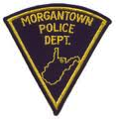

Motorist

Bicyclists have the same rights to the road as motorists and must obey the same rules.

You Must:
- Yield right-of-way to a cyclist just as you would yield to another vehicle. (This means not pulling out in front of a moving cyclist or cutting them off.)
- Allow a safe distance when passing a cyclist: at least 3 feet to the side
- Only pass when you can see far enough ahead to complete the pass without interfering with the safe operation of any vehicle or bicycle
- Obey the speed limit
- Pay attention to your driving

Morgantown Police Department
300 Spruce St.
304-284-7454

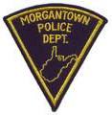

Bicyclist

Bicyclists have the same rights to the road as motorists and must obey the same rules.

You Must:
- Stop for stop signs and red lights
- Ride with, not against traffic
- Signal stops, sideways movements and turns
- Yield right-of-way to vehicles and other bicycles when you do not have the right-of-way
- Not ride on sidewalks or crosswalks. (They’re for pedestrians.)
- Use a white front headlight and red rear reflector after dark
- Wear a helmet

Maximize your visibility and predictability. Ride where motorists can see you. Obey the law.

Morgantown Police Department
300 Spruce St.
304-284-7454

