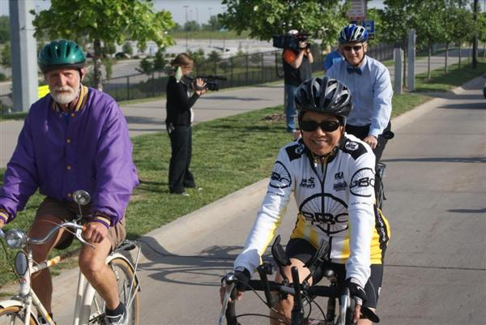
You are Invited to Join
WV Connecting Communities
and
Mountain State Wheelers Bicycling Club
for a
Legislative Bike Ride
When: Sunday, October 20, 2013 3:30 p.m. to 5:00 p.m.
Where: Plaza side of Capitol (outside by the stage)
Why: Join us for some fun and exercise as we take a leisurely bike ride through Charleston.
Please RSVP by Oct. 17th to Kasey Russell, 304.542.1994 or Russell.kasey@gmail.com.
Be sure to bring your bike and helmet to town for this inaugural event, or
If you do not have a bike and helmet, let us know and we will secure one for you.

For more information about WV Connecting Communities, please visit our website, www.wvconnectingcommunities.com.

