To: City of Morgantown
City Manager’s Office
From: The Morgantown Municipal Bicycle Board

Thank you for your October 31 request for Bicycle Board input on electronic shared scooters. This is the Bicycle Board’s response. It is divided into the following sections.
- What are electronic shared scooters?
- Benefits
- Concerns
- Recommendations
- References

What are electronic shared scooters
Electric scooters are small lightweight personal transportation devices resembling the Razor scooters popular among tweenagers beginning in the 2000. E-scooters first became popular in China and most are manufactured there.
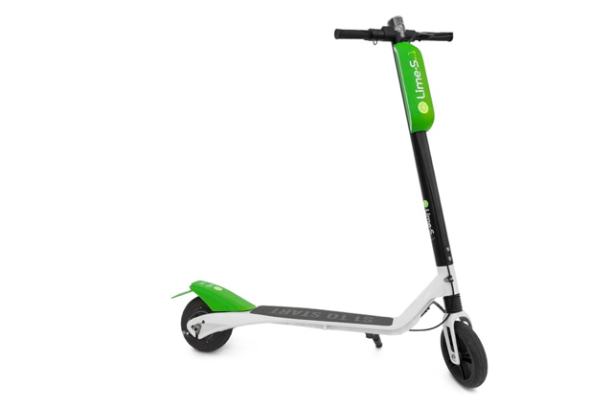
How to Ride a Lime: https://youtu.be/zOMYOBBRtM8

In general, e-scooters have small electric motors of approximately 250 W (1/3 horsepower): about twice the power output of an average leisurely cyclist, can travel at speeds up to approximately 15-mph and can go approximately 20-miles on a charge. Small e-scooters require a kick to start moving and perhaps to get up to speed especially when going uphill. They are equipped with a throttle to regulate speed and a hand brake to stop the rear wheel. Some have regenerative braking in the front drive wheel. Braking could be marginal on the steep downhills that we have in Morgantown.

Shared e-scooter systems include docked and dockless. Docked require the rider to park the scooter at docks erected at fixed locations.

Dockless e-scooters contain a GPS system that enables it to be tracked. Shared e-scooters generally are accessed by cell phone app that enables the user to locate a scooter, determine how much charge is in the battery, pay for it, unlock it and lock it at the destination.

Dockless systems allow the rider to park the scooter in any legal location. Using the cell phone to lock a dockless e-scooter fixes the wheels and the scooter will sound an audible alarm if someone moves it without first unlocking it.

Xiaomi in China is a major e-scooter manufacturer and at least two major US shared e-scooter system vendors Bird and Spin re-brand Xiaomi products. Some shared e-scooter vendors include, Lime, Bird, Spin, Scoot and Skip
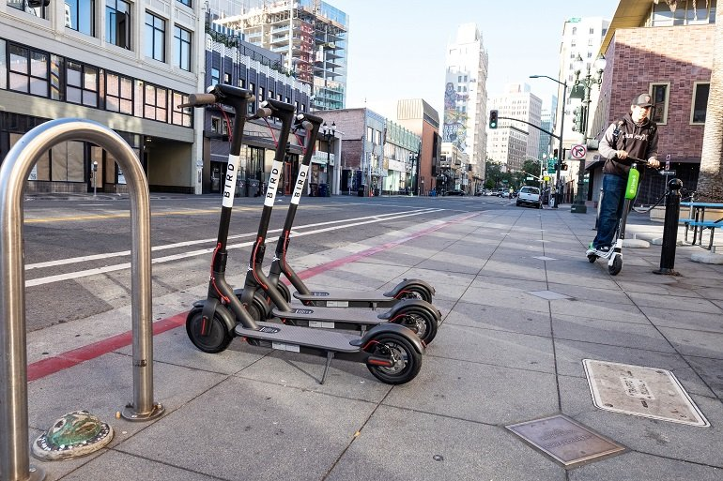

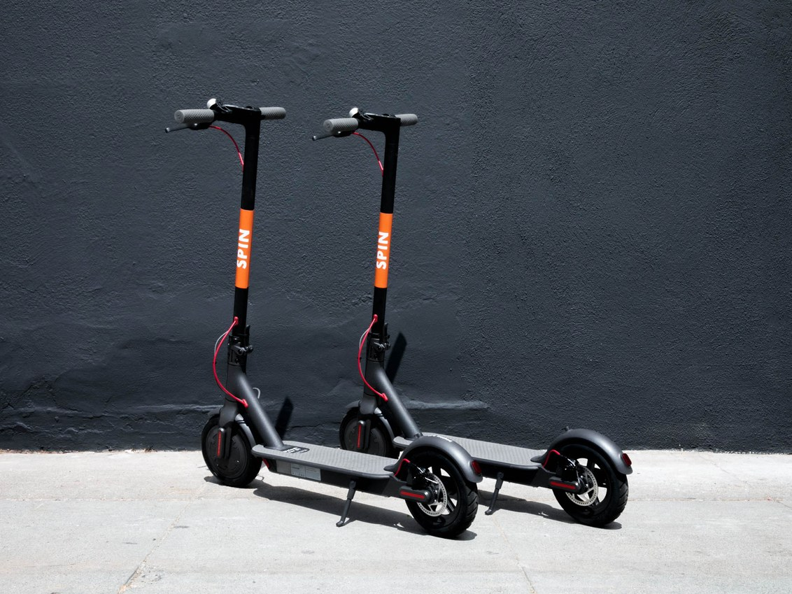

Benefits and Concerns
For Morgantown, shared e-scooters can:
- Mitigate traffic congestion
- Provide net positive revenue stream to the City
- Improve public health
- Improve local transportation equity

Typical concerns about shared e-scooters include:
- Where will we ride them: streets, bike lanes, sidewalks?
- Where will we park them?
- How safe are they?
- What’s the business model?

We elaborate these points below.

Mitigate Traffic Congestion
Electronic shared scooters offer a new opportunity to mitigate Morgantown’s greatest problem, traffic congestion. E-scooters are a good fit for a large percentage of trips around town. Nationwide, 50% of all trips are less than 5 miles. Morgantown is only 5-miles across. More than 18% of people who live or work in Portland, OR said if an e-scooter weren’t available for their last trip, they would have taken a personal vehicle, car-share vehicle, or other motor vehicle.

E-scooters can fill a niche between walking and bicycling in the spectrum of transportation choices ranging from walking to single occupancy motor vehicles.
“From ride-hailing to self-driving cars to electric cars, billions of dollars are pouring into companies that move people around. But short trips between apartments and metro stops or leisurely rides across parks remained a vacuum until recently.”

40% of all vehicle trips are less than 2-miles. “Urban journeys are becoming increasingly multimodal, and scooters may add one more flexible link to the transit chain rather than replacing another mode completely. Their most valuable traits are how flexible they are compared to public transit, which runs fixed routes, and how cheap they are compared to cars. That means scooters fulfill a unique niche of the transportation ecosystem.” A 2-mile ride takes about 10 minutes and costs less than $3 and when you get to your destination, you don’t have to drive around the block looking for a parking spot.

Their small electric motors can make climbing Morgantown’s hills easier. Their low mass and low speed makes them less of a threat of injury to other travelers than heavier and faster vehicles. Their small size minimizes space for storage and parking. Their small size and simplicity relative to other motorized transportation options minimizes capital and operating costs. They can also help reduce obesity, improve personal health and reduce the negative environmental impact of our other motorized transportation systems.

Provide a net positive revenue stream for the City
Licensing agreements can be structured to provide revenue to the City. In Austin, TX officials are charging companies $100 a bike or scooter during its experimental phase, and could raise tens of thousands annually. Mobility startups operating in Santa Monica, CA have shelled out a $20,000 each for the right to operate, plus $130 per each device on the street, plus $1 per device per day for the privilege of parking on the public sidewalk. (That last charge is modeled off the way the city charges restaurants for outdoor dining.) Participants’ in Los Angeles’ soon-to-launch scooter and bike program will have a similar setup. Portland, OR is charging the companies operating there a 25-cent per trip fee. Seattle, WA charges the vendor $50/bike, half of which goes to building light personal transport infrastructure. San Francisco, CA requires each of its two permitted e-scooter-share companies to pay $25,000 for an annual permit, plus $10,000 to an endowment fund for city property repair and maintenance. Kansas City, MO is considering scooter fees to support affordable housing. Of course, these raise the question, “what is the minimal feasible number of e-scooters?” Is Morgantown’s market large enough? City government decisions could make the difference.

E-scooters enjoy large venture capital investments that enables those companies to rapidly develop their businesses, products and marketing, etc. and avoid the typical start-up early stage bankruptcies that plagued bike share companies.
“Some scooter firms are already “unicorns” — privately held companies valued at more than $1 billion. Bird, based in Santa Monica, doubled its valuation to $2 billion in just four months. Lime, which also rents bikes, crossed the $1.1 billion valuation mark just 18 months after it launched. Skip Scooters is valued at $100 million.”

“Meanwhile, Uber and Lyft are themselves getting into the electric scooter game. In early September, Lyft launched 250 scooters in Denver. Uber bought Jump Bikes, an electric bike rental service, for $200 million in April.

Improve public health
“I work in some of the most obese, hot, behind the cultural shift, and behind the bike culture shift, communities,” said Lindsey Gray West, who helped start the Birmingham, Alabama, bike-share program and now runs Bantam Strategy Group, a bike-share consulting firm in Baton Rouge, Louisiana, that works almost exclusively with Southern cities.
But scooters have been an easy sell, she said. “Just in the last two weeks probably I’ve had multiple city councilmen, multiple mayors over the age of 70, all at least 50 and older, that have come back and said, ‘This is the best thing I’ve ever done.’”
... in Birmingham: It’s hot, it’s hilly, and people don’t want to show up for business meetings drenched in sweat.”

E-scooters can reduce air pollution. E-scooters being electric release no fumes during operation however the electricity they consume is generated somewhere and most often that’s coal-fired power plants. E-scooters consume a few thousandths the energy of cars and so produce a few thousandths the amount of air pollution of cars whether the cars be electric, hybrid, gasoline or diesel. However, e-scooters that replace walking or bicycling trips add to air pollution albeit little. E-scooter materials, especially lithium ion batteries present significant impact on the environment when they enter the waste stream. While not as significant as from automobiles and other technologies, e-scooter environmental impact cannot be ignored.

E-scooters can mitigate obesity. Although not exactly “active transportation” such as walking or bicycling, e-scooter riders burn more calories and use more muscles than motor vehicles drivers.

E-scooters can build social capital and civility. Our private automobiles and our electronic technology can isolate us from face-to-face personal interactions that can include synergizing, creating, problem solving and just plain fun.

Improve local transportation equity
Scooters are bringing cheap transportation to people who may otherwise not have used it. They effectively expand the range of neighborhoods, allowing residents to easily travel further and increasing the reach of businesses. Researchers have found that mobility is a critical rung in the ladder out of poverty. That may explain why electric scooters have a better reputation with people of lower incomes…”

“Though not everyone owns a car, everyone pays for one. There are roughly eight parking spots for every car in the United States, and free parking amounts to a subsidy to car owners of more than $100 billion a year.”

“This means there’s a strong case for demanding concessions from car infrastructure to facilitate walking, biking, and scooter riding — transit options that are more equitable and easier to access. That is, narrower roads in favor of larger bike lanes and sidewalks.” Where there’s a will, there’s a way:”

CONCERNS

Where will we ride them: streets, bike lanes, sidewalks?
Perhaps, “All of them as appropriate!” The key to a successful transportation system is a continuous network connecting all origins and destinations. For example, a Privately Owned Auto from the suburbs to a Park-N-Ride; a Mountain Line bus to a City bus stop; a shared e-scooter from the bus stop to work or school; a shared e-scooter to meetings around town or classes on different campuses and back to the bus stop and the bus back to the Park-N-Ride.

With many alternative modes of transportation appearing and more to come, it’s time to re-allocate and redesign public space, update ordinances governing the use of public space to optimize the transportation system for all users, educate users on the changes, and enforce the changes. This is the Complete Streets concept. The City, the County, and the State have established Complete Streets policies.

Motorists and pedestrians are not the only users of public space. The advent of electric assisted and electric powered bicycles and scooters has blurred the dividing line between “motor vehicles” and “non-motorized vehicles.” The impending appearance of e-scooters should prompt Morgantown to update its plans for optimizing our public space.

WVDOH cooperation and collaboration in a successful transportation system is essential since any trip across town and indeed through many neighborhoods involves using state maintained roads. One reason cyclists and other light individual transport (LIT) users take the sidewalks rather than the streets downtown is that the one-way streets and long signal cycles are practically as inefficient as imaginable for a law abiding LIT traveler. Another reason that bicyclists take the sidewalks is that they are not trained to use the streets as drivers of vehicles, which they are under the law, and law enforcement officers while barely enforcing sidewalk cycling laws do not encourage roadway use. Even they appear to be afraid to use them. Fortunately, the City is now installing shared lane markings and bike lanes on City maintained streets. Perhaps success at getting more cyclists using the streets safely will encourage WVDOH cooperation and collaboration.

Where will we park them?
With approximately 1/3 of Morgantown’s land allocated to empty motor vehicles, we should be able to enable convenient e-scooter parking! A dozen e-scooters could park in the space of one automobile. Parking a dockless e-scooter anywhere can present obstructions to other travelers but this can be addressed by the proper ordinances and permitting requirements. Limiting the number of e-scooters to those that get 3-4 rides/day is one way of ensuring that they are being used rather than cluttering the parking areas. Of course, the vendor would have to share usage data with the City to know how many rides each scooter gets.

How safe are they?
“The biggest safety issues right now stem from inexperience. Given how new scooters are, there’s no consistent etiquette for riding an electric scooter, and so pedestrians, drivers, and cyclists can’t necessarily anticipate what a scooter will do in an intersection, which can lead to conflicts (read: collisions).”

“Establishing a set of best practices (and actually following them) would go a long way toward smoothing out the tensions between different modes of transport and solving the safety issues around scooters. This would require regulation from cities and education from scooter companies.”

“Given that they are low speed and lightweight, dockless scooters and bikes pose a very low safety risk to the public. Cities can relax or eliminate laws for these types of devices that were intended for faster and heavier vehicles. Instead of using resources to cite those not wearing helmets, cities should focus on making streets safer by encouraging the spread of these non-vehicular services and limiting motor vehicle speeds to improve safety for all people on foot, scooter, or bicycle.”

What’s the business model?
City-vendor collaboration is probably key to positive outcomes for both. Since e-scooter companies are well capitalized compared with bike share companies, they can afford to cover most of the expenses that cities worry about, provided they still make sufficient profit.

““Beyond cities, private companies need to work proactively with local governments to improve the communities in which they operate. After stirring up controversy in San Fransciso, the dockless scooter provider Bird released a three-part plan to address cities’ concerns, promising to retrieve all of their devices from city streets every night, to not increase the number of devices in their fleet unless they are being used an average of three times a day, and to provide $1 per scooter per day to city governments for infrastructure improvements. Such considerations play an important role in operating a transportation network that serves all citizens.”

“The deployment of dockless mobility is a great way for cities to experiment with providing new transportation options to citizens for two reasons. First, dockless services do not directly utilize public dollars. Unlike many docked bike share systems, the private companies are fully funding the capital and operating expenses associated with their systems. Cities only need to provide the administrative and oversight functions, but these are relatively small compared to the broader transportation portfolio.

Second, dockless deployment is a safe experiment when considering that cities already allow large vehicles to navigate city streets at high speeds. In 2016, there were 37,461 deaths on U.S. roads attributable to vehicle drivers. And though there are parallel traffic laws imposed on vehicles—speed limits, for instance—these laws are regularly disobeyed with little enforcement or accountability.

Beyond cities, private companies need to work proactively with local governments to improve the communities in which they operate. After stirring up controversy in San Fransciso, the dockless scooter provider Bird released a three-part plan to address cities’ concerns, promising to retrieve all of their devices from city streets every night, to not increase the number of devices in their fleet unless they are being used an average of three times a day, and to provide $1 per scooter per day to city governments for infrastructure improvements. Such considerations play an important role in operating a transportation network that serves all citizens.

There will be kinks along the way as users learn where and how to appropriately use the mobility devices. And it is impossible to know whether the dockless systems are a 2018 fad or will eventually be part of the broader transportation network. But by creating smart regulations for dockless services, cities can encourage new mobility options and ultimately fulfill their long-term goals of creating safe, equitable, sustainable mobility.”

“July data from Charlotte, NC which currently has Lime and Bird scooters and several dockless bike companies operating at the same time — shows that the scooters are much more popular (than share bikes). In July, residents took 100,273 trips on e-scooters, compared to 27,453 trips on bikes, the city government reports.

And even more telling: Each e-scooter was rented an average of four times a day compared to .6 rides per day for the dockless bikes, which has roughly double the fleet size.

Also surprising: people are taking the scooters on longer trips than the bikes, with an average e-scooter trip of 1.4 miles vs. 0.74 miles for the bikes, Charlotte’s data shows.”

San Francisco’s shared e-scooter permit requirements provide one excellent example of what Morgantown should be considering. Vendor permit applications provide valuable insights into how vendors can meet them.

For example, consider the concern about parked e-scooters “cluttering” sidewalks and obstructing other travelers. Skip describes “lock to” and other technological innovations that require users to lock to physical objects. Skip is also working to locate the “lock to objects” in poorly utilized space such as tiny spaces that parking automobiles can’t use at the ends of blocks. They are also working on an “end of ride” Free Ride Incentive for Perfect Parking Compliance that requires users to certify that they are parked properly in designated areas, specifically noting that they have not parked in specific prohibited areas (foot traffic, curb ramps, entryways and traffic zones). Taking a picture and sending it to the vendor is one way to do this.

RECOMMENDATIONS
- Assistant City Manager organize and lead a light individual transport (LIT) working group. Recommended members to include:
City Attorney (Simonton),
Bicycle Board (Gatlin),
Greenspace Coalition (Landenberger)
Pedestrian Safety Board (Cross),
Metropolitan Planning Organization (Zhang),
Morgantown Parking Authority (King),
Mountain Line rep (Bruffy),
Morgantown Police Department (McCabe),
Morgantown Engineering/Public Works (Stockdale),
WVU (Haas),
WVDOH (?)
- Identify any WV Code “showstoppers”. If none, proceed.
- Issue to potential electronic ride-share scooter system vendors (Bird, Drop, Lime, Scoot, Skip, Spin) a Request for Expression of Interest (REI) in a nominal two-year electronic ride-share scooter pilot program. In REI, ask vendor to discuss:
  - Hardware and software descriptions / specifications / examples / demonstrations
  - Experience and qualifications
  - Minimum market for viable business
  - Pricing structure
  - Fleet size and service area
  - Plans for
    - Safe riding and storage/parking
    - Scooter operation and control including app description / demo
    - Recharging
    - Maintenance
    - Distribution
    - Customer service
    - Human Resources
    - Data sharing with the City
  - Insurance
  - Indemnification of the City
- Amend ordinances to remove barriers to light individual transportation devices including electric scooters.
- Establish and implement a data collection plan and decision criteria and process for continuing from the pilot to a permanent program.

I hope you will find this response useful. The Bicycle Board looks forward to collaborating with you and other key stakeholders to optimize Morgantown’s transportation system. Please do not hesitate to contact me if I may be of further assistance.

Drew Gatlin

References

CNET, “The electric scooter war continues. Here's how they work (FAQ)”. https://www.cnet.com/news/electric-scooters-bikes-dockless-ride-share-bird-lime-jump-spin-scoot/ May 31, 2018
CNET, “The electric scooter war continues. Here's how they work (FAQ)”. https://www.cnet.com/news/electric-scooters-bikes-dockless-ride-share-bird-lime-jump-spin-scoot/ May 31, 2018
Federal Highway Administration, 2009 National Household Travel Survey (NHTS), https://nhts.ornl.gov/tables09/fatcat/2009/vt_TRPMILES.html
PBOT, 2018 E-scooter Pilot User Survey Results, https://www.portlandoregon.gov/transportation/article/700916
Vox, “Electric scooters’ sudden invasion of American cities, explained”, https://www.vox.com/2018/8/27/17676670/electric-scooter-rental-bird-lime-skip-spin-cities Sep 7, 2018
Federal Highway Administration, 2009 National Household Travel Survey (NHTS), https://nhts.ornl.gov/tables09/fatcat/2009/vt_TRPMILES.html
Vox, “Electric scooters’ sudden invasion of American cities, explained”, https://www.vox.com/2018/8/27/17676670/electric-scooter-rental-bird-lime-skip-spin-cities Sep 7, 2018
Vox, “Electric scooters’ sudden invasion of American cities, explained”, https://www.vox.com/2018/8/27/17676670/electric-scooter-rental-bird-lime-skip-spin-cities Sep 7, 2018
Vox, “Electric scooters’ sudden invasion of American cities, explained”, https://www.vox.com/2018/8/27/17676670/electric-scooter-rental-bird-lime-skip-spin-cities Sep 7, 2018
WIRED, Aarian Marshall, “MILKING SCOOTERS FOR CASH HELPS CITIES BUILD FOR THE FUTURE”, https://www.wired.com/story/scooters-cities-fees-mobility/ Nov. 6, 2018
Vox, “Electric scooters’ sudden invasion of American cities, explained”, https://www.vox.com/2018/8/27/17676670/electric-scooter-rental-bird-lime-skip-spin-cities Sep 7, 2018
Vox, “Electric scooters’ sudden invasion of American cities, explained”, https://www.vox.com/2018/8/27/17676670/electric-scooter-rental-bird-lime-skip-spin-cities Sep 7, 2018
Morgantown Adopted a Complete Streets resolution December 5, 2007, https://www.morgantownwv.gov/DocumentCenter/View/387/Complete-Streets-Resolution-PDF?bidId=
Guidance for Regulation of Dockless Shared Vehicle and Sample Ordinances International Municipal Lawyers Association, Guidance for Regulation of Dockless Micromobility ATTACH PDF OR LINK TO IT IN AT STABLE URL Boulder, CO Dockless Bike Share Ordinance, https://www-static.bouldercolorado.gov/docs/Errata_Sheet_Ord_8246_6.12.18_mtg_dockless_bike_share-2830-1-201806121602.pdf?_ga=2.95866908.1252086740.1542042165-1306151735.1542042165 June 12, 2018 Dallas, TX Dockless Vehicles Ordinance Discussion, https://www-static.bouldercolorado.gov/docs/Errata_Sheet_Ord_8246_6.12.18_mtg_dockless_bike_share-2830-1-201806121602.pdf?_ga=2.95866908.1252086740.1542042165-1306151735.1542042165 June 6, 2018 Columbus, OH Regulations on Shared Mobility Devices, https://www.columbus.gov/Templates/Detail.aspx?id=2147505480 August 28, 2018 San Francisco Powered Scooter Share Permit Pilot Program requirements: https://www.sfmta.com/sites/default/files/reports-and-documents/2018/04/5-1-18_item_11_pilot_scooter_share_program_permit.docx_.pdf April 25, 2018 Charlotte, NC Bike Share Permit Requirements, https://charlottenc.gov/Transportation/Programs/Documents/CharlotteBikeSharePermitRequirements.pdf October 13, 2017 Santa Monica, CA City Code Amendments pertaining to e-scooters, http://www.qcode.us/codes/santamonica/ ~September, 2018 Washington, DC Dockless Shared Vehicle Permit Requirements (Draft), https://ddot.dc.gov/sites/default/files/dc/sites/ddot/page_content/attachments/Dockless%20Terms%20and%20Conditions%20-%202019%20-%20Scooters%20-%2011.02.18.pdf
Vox, “Electric scooters’ sudden invasion of American cities, explained”, https://www.vox.com/2018/8/27/17676670/electric-scooter-rental-bird-lime-skip-spin-cities Sep 7, 2018
Eno Transportation Weekly, Brianne Eby, “The U.S. Dockless Mobility Experiment” https://www.enotrans.org/article/the-u-s-dockless-mobility-experiment/ Week of April 23, 2018
Eno Transportation Weekly, Brianne Eby, “The U.S. Dockless Mobility Experiment” https://www.enotrans.org/article/the-u-s-dockless-mobility-experiment/ Week of April 23, 2018
Streetsblog USA, “Charlotte Provides the Most Compelling Evidence for E-Scooters Yet”, https://usa.streetsblog.org/2018/08/30/the-most-compelling-evidence-for-e-scooters-yet/ , Aug. 30, 2018
San Francisco Powered Scooter Share Permit Pilot Program requirements: https://www.sfmta.com/sites/default/files/reports-and-documents/2018/04/5-1-18_item_11_pilot_scooter_share_program_permit.docx_.pdf April 25, 2018
San Francisco Shared Powered Scooter Permit Applications Bird SFMTA Scooter Permit Application, https://assets.documentcloud.org/documents/4517223/Bird-SFMTA-Scooter-Permit-Application-June-2018.pdf Lime SFMTA Scooter Permit Application, https://assets.documentcloud.org/documents/4517225/Lime-SFMTA-Scooter-Permit-Application-June-2018.pdf Scoot SFMTA Scooter Permit Application, https://assets.documentcloud.org/documents/4517220/Scoot-SFMTA-Scooter-Permit-Application-June-2018.pdf Skip SFMTA Scooter Permit Application, https://assets.documentcloud.org/documents/4517227/Skip-SF-MTA-Scooter-Permit-Application-June-2018.pdf
Bird SFMTA Scooter Permit Application, Page 11 of 21 https://assets.documentcloud.org/documents/4517223/Bird-SFMTA-Scooter-Permit-Application-June-2018.pdf

