FY’ 2017 TAP Grant Options
- White Park / Rail-Trail Connector on Don Knotts: ADA ramp and pedestrian crossing at Sargasso traffic light.
  - This project was mentioned in three separate meetings outside of today’s: our October general meeting, a mapping meeting between Vaike Hass, John Whitmore, Derek, and I last week, and a meeting between Damien and Chris Fletcher. Two versions: one is a million-plus dollar pedestrian bridge across Don Knotts, that would have to be funded in phases. The other is an ADA ramp up 12’ of hillside to meet up with an existing White Park trail. This is immediately adjacent to the light at the intersection with the entrance to the building that houses MedExpress / Sargasso. Improvements to this light system (including Ped-Heads and a nice big crosswalk) are included with the plan.
  - We are leaning towards the latter option – Damien believes it is likely to cost significantly less than $500K and is very likely to be funded.
  - Damien and I talked about expanding the funding request to improve the trail that meets the ADA ramp. We need more details on what types of improvements should be made if we are to pursue the expansion.
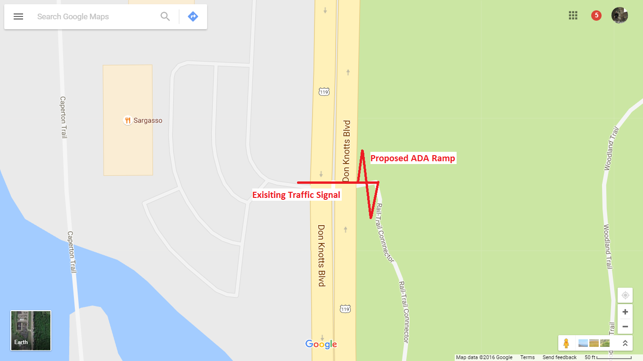
- Collins Ferry Sidewalk: Another one to come out of the engineering/planning departments.
  - Sidewalk on the West/Southwest side of Collins Ferry, will likely cost at least $500,000. Provides safer, ADA compliant route for children walking (and likely biking) to the new elementary school. The sidewalk on the opposite side of Collins Ferry is inundated with utilities and is in generally poor repair.
  - Seems like this project is popular.

- The campus connector / Grant Street trail: from Autozone to the President’s House.
  - Completion of this trail may go a long way to cutting down on vehicular traffic from Sunnyside to the coliseum. Major current issue is one uncooperative landowner, but this family was last approached a while ago. Might be time for a refresh of the conversation.
  - Does anyone know anything about or have access to designs that were created in the past for this project?
  - We talked about providing a match for the grant by diverting our striping funds away from the Mon Boulevard project, given that those funds have not been spent since 2007. We could raise more money in the future for Mon Blvd climbing lane if that project becomes a reality.
  - WVU should probably spearhead this project
- A tunnel under WV705 about 100 yards from Eastwood Elementary
  - Super awesome cool very relevant idea uncovered / suggested by Vaike Haas and her students. There is an existing livestock tunnel that, if expanded, would provide a direct connection between two major projects and link the mileground communities to downtown and Evansdale. (These projects are the shared-use path from the roundabout to Willowdale along 705 and the Falling Run trail project).
  - Existing tunnel is too small for adults to comfortably pass through (and impossible for two-way traffic to pass), but elementary classes have used the tunnel in the recent past to visit the WVU organic farm.
  - Soil above the tunnel is extremely thin – base of pavement likely rests directly on the tunnel. There is an existing crack in the pavement that follows the tunnel exactly. WVDOH will need to repair this and other defects along 705 in a short manner anyhow; we may want to convince them to rope this project in with their reconstruction efforts.
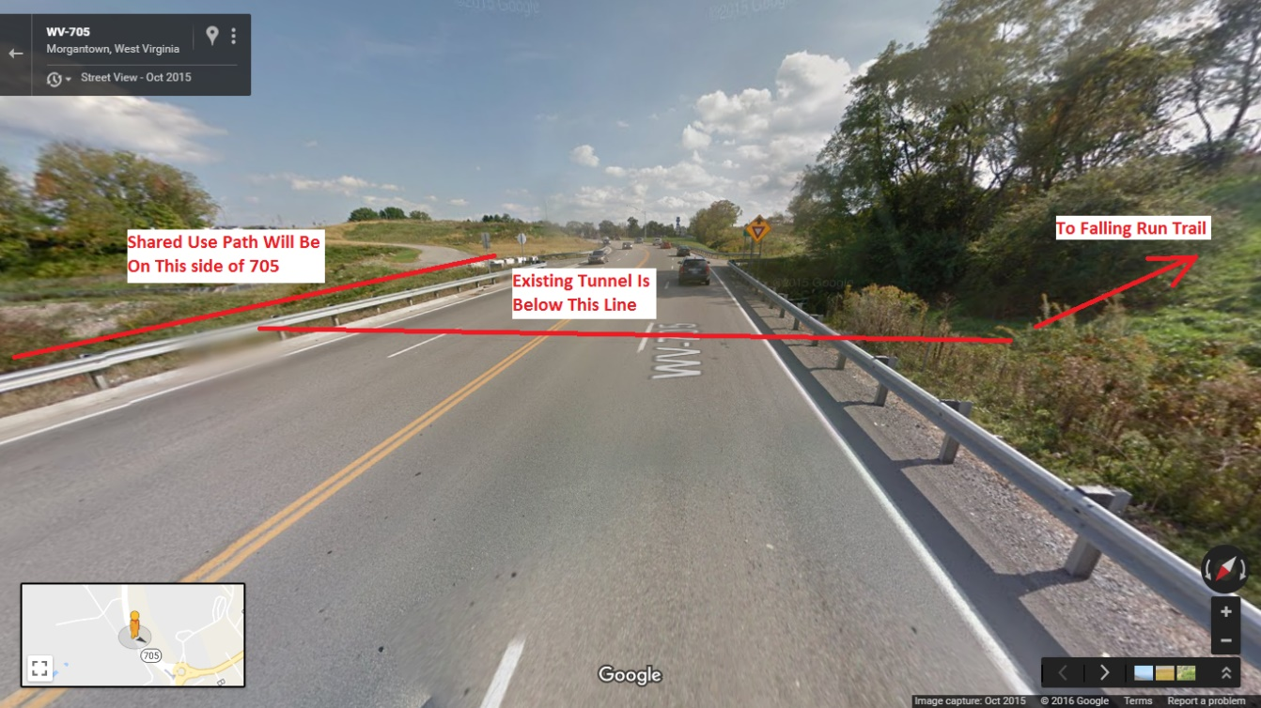
- The Jones Bypass
  - The Jones Bypass would be an alternative, or at least supplementary, solution to the University Avenue Corridor complete streets initiative. Jones is a low-volume neighborhood street that parallels University from Stewart to (nearly) Riverview – the entire length of University that is a concern for those traveling from downtown to Evansdale. The connection with Riverview is accomplished either on foot or bicycle by venturing briefly onto the law campus. This cut through is often used.
  - This project requires two major design considerations: the transition from University to Jones via Stewart Street, and the one-way segment of Jones from Overhill to Stewart (hint: it’s one-way the wrong way). See below:
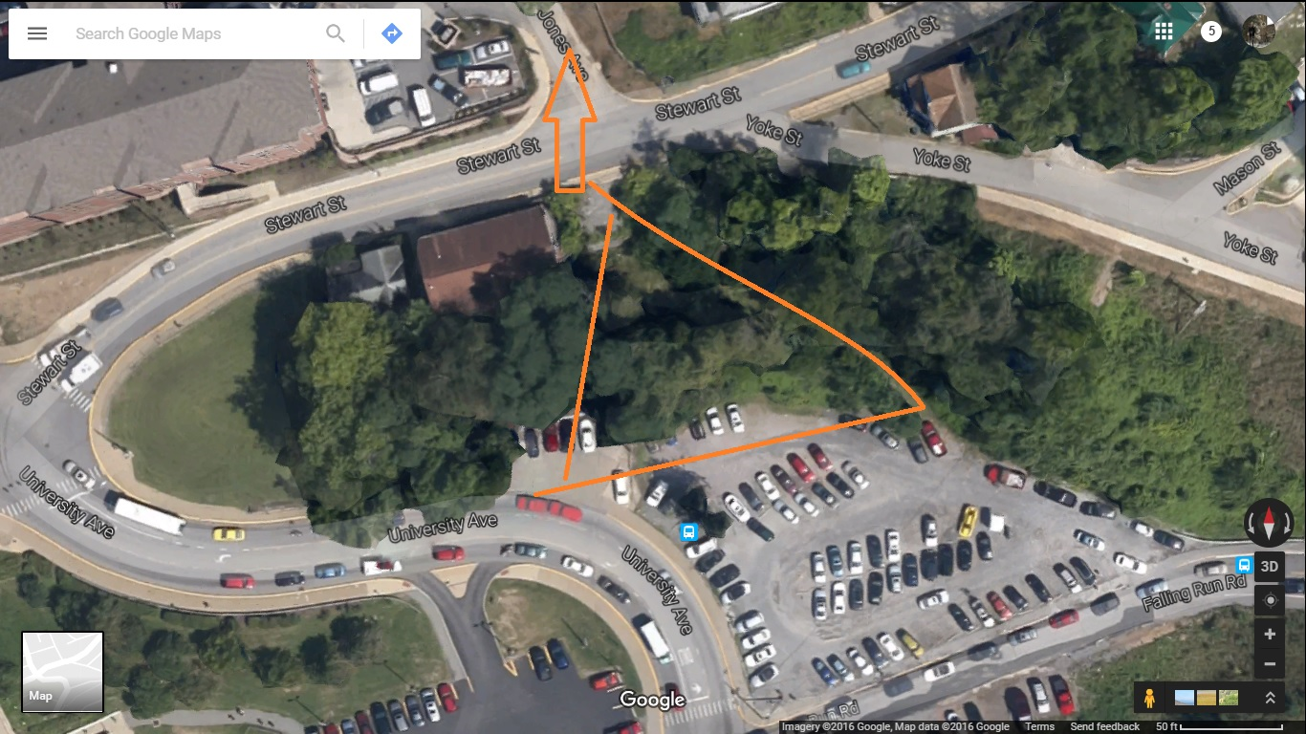
  - A review of precedents around the US for allowing two-way bike traffic on a one-way street would accomplish the latter consideration. We would likely have to remove the remaining parking on that section of Jones.
  - This project requires cooperation with WVU and may be able to be achieved without TAP grant funding. Jones is scheduled for paving next year.
- More funding for the Mon. Blvd climbing lane. Namely, to stabilize the rockfall.
  - This project was suggested somewhat facetiously, from what I gather – the DOH / WVU should take care of the situation for a multitude of reasons beyond the climbing lane. Also, bank stabilization is well out of our purview and / or expertise.

