Bicycle Parking Press Release

To encourage more Morgantown residents to ride their bikes, the City of Morgantown is installing bicycle-parking devices downtown.

Now, a bicyclist can securely lock his or her bicycle to a designated bicycle-parking device rather than to a tree, trashcan or other street object.

The post-and-loop parking devices are cleverly designed so that a bicyclist can pass his or her lock through the bicycle frame and wheels and then through the parking ring and around a post.

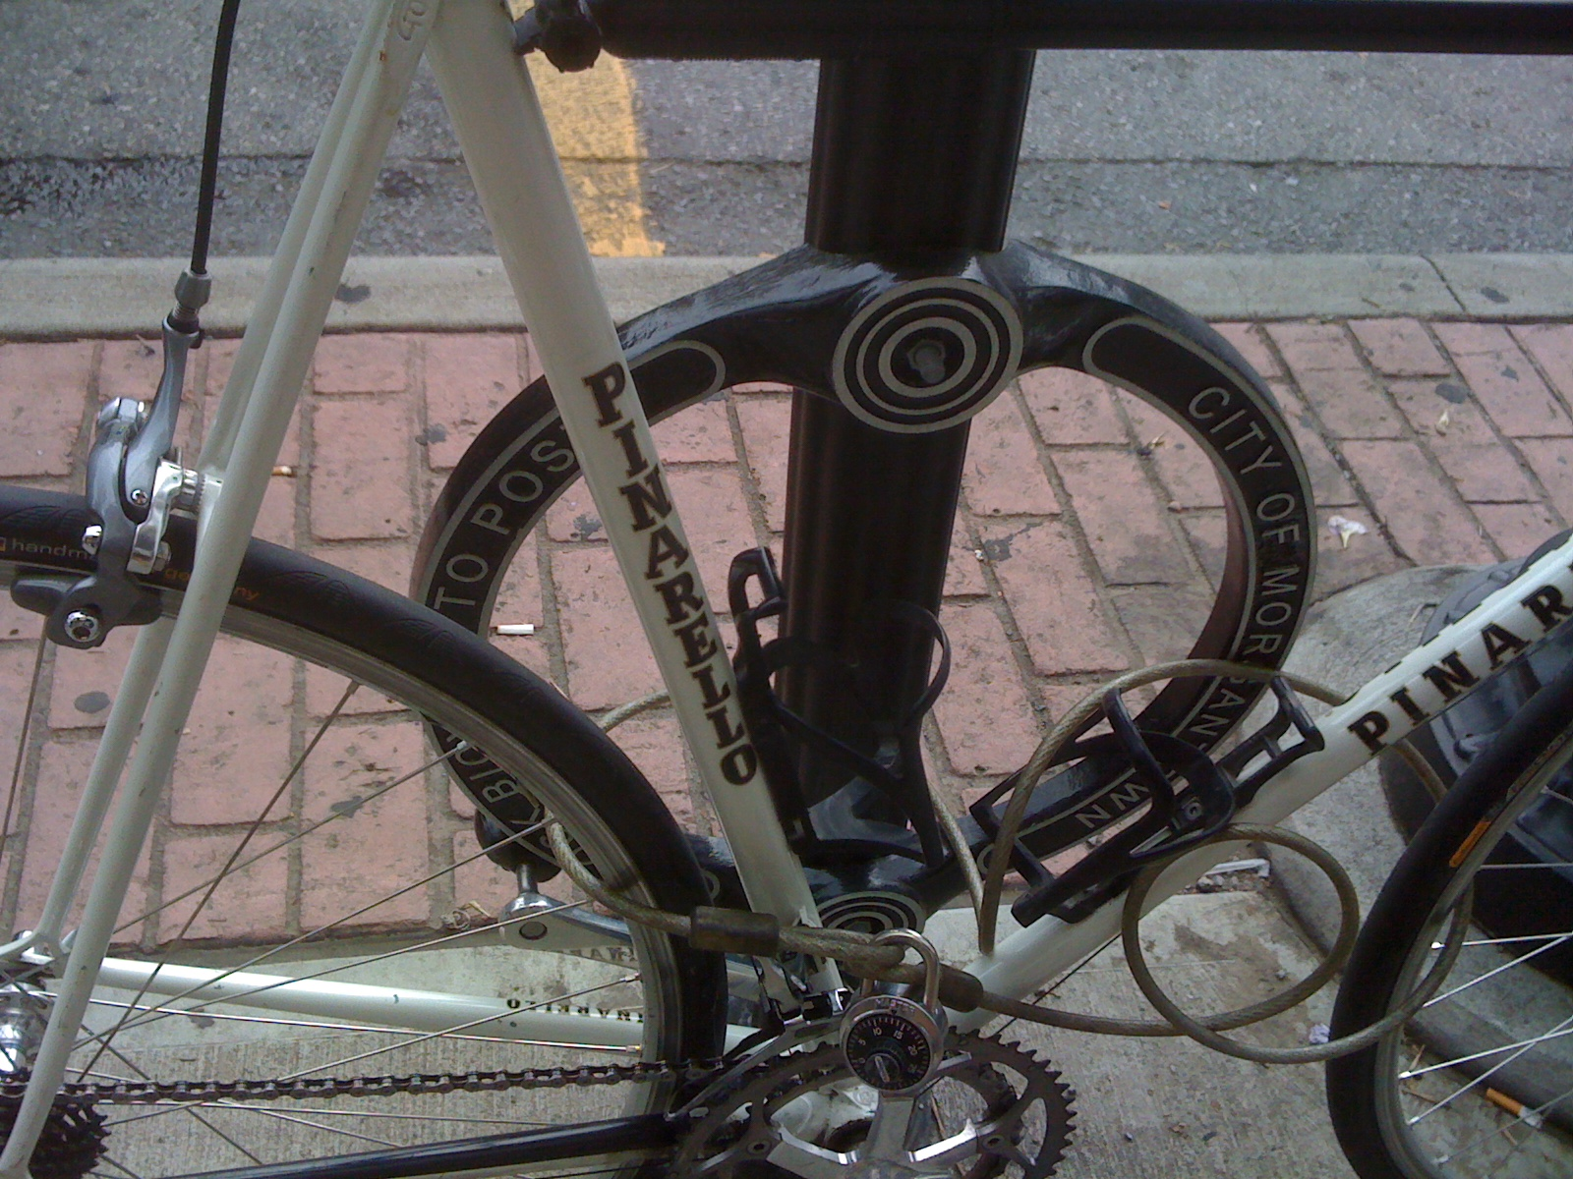

The Parking Authority is installing most of the post-and-loop devices on select parking meter posts on High Street and Walnut Street but a few stand-alone devices will be installed in high demand locations where a parking meter is not handy, such as beside the Public Safety Building.

Our post-and-loop design was pioneered in Toronto where they now have nearly 13,000 installed and downtown merchants continue to ask for more. Matthews International, a Kingwood WV company manufactured our rings.

The Morgantown Municipal Bicycle Board spearheaded the bicycle parking effort. The post-and-loop parking devices are good for short-term bicycle parking. For longer term parking, the Bicycle Board is working with the Parking Authority to provide secure bike lockers in the City parking garages. In the long range, the Bicycle Board intends for residents to have secure bicycle parking at all popular city destinations.

Bicycling downtown takes up less space on the streets and reduces congestion. Every bike locked to a bike rack frees up a parking space for a car. With residents coming to town by bike, on foot and by bus as well as by car, residents can spend less time looking for parking, our downtown can be more vibrant and businesses can expect increased sales.

How many of us have as many bicycles hanging in the garage as cars in our driveways? Having a place to lock up your bike at your destination removes one major obstacle to using it.

Bicycle parking is just one Bicycle Board initiative. As part of its broad program to make Morgantown a bicycle-friendly community, the Bicycle Board is planning and implementing improvements in bicycling-related engineering, education, enforcement, encouragement and evaluation.

Morgantown becoming a bicycle-friendly community will support the local economy, reduce traffic congestion, and improve the quality of life and neighborliness for all.

The Bicycle Board thanks Marchetta Maupin and the Beautification Committee for providing the design; Tom Arnold and the Parking Authority for working with the Board to finalize the design and for installation; the City Engineer's office for identifying installation challenges; Mainstreet Morgantown for reviewing and approving the plans; ; Dan Boroff for budgeting for the devices; City Council for approving the budget and Jennie Selin, Don Spencer, Gunnar Shogren, Betsy Shogren, Ryan Post, Alice Vernon, Marilyn Newcome, Derek Springston and Chip Wamsley for braving all kinds of weather to identify optimal locations for the devices.

