On-road Cycling Infrastructure

What’s with all these new signs and pavement markings around town?
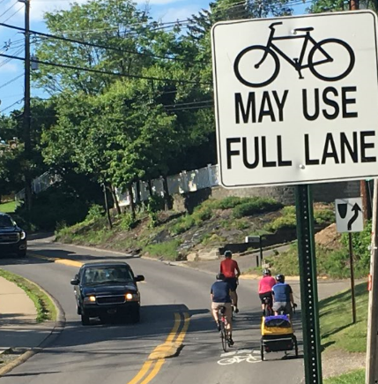
Figure 1 – Sharrows on Willowdale Road (photo courtesy Traci Knabenshue)
With the benefits of active transportation and recreation increasingly apparent, cities around the United States are looking to tackle real and perceived threats to safety when choosing to travel via bicycle. Recent reviews of crash data found cyclist injuries and fatality rates in the United states nearly four times greater than those in other high-income, developed countries (Pucher 2016). Installation of infrastructure specifically designed with cyclists in mind can improve these safety outcomes. Such expenditures can also pay dividends by sending friendly signals to the estimated 60% of on-the-fence citizens who are “interested but concerned” with the dangers of riding bikes on the roads (Dill 2013).
Morgantown aims to join other forward-thinking communities around the world that modify roadways to better accommodate and encourage bicycling. Although cycling here can seem daunting due to the narrow roads and steep hills (particularly for out-of-towners!) we hope our investments will inspire you to hop back on your saddle and enjoy Morgantown on two (human powered) wheels. We’ve built this document to describe the different types of on-road bike infrastructure you’ll encounter, why they might suit a given road, and how you can expect them to work for all users of our transportation system.
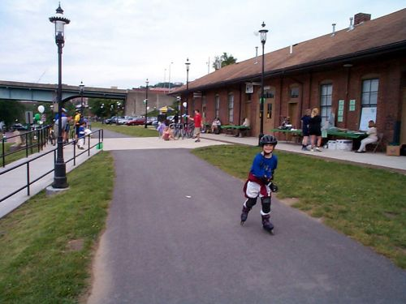
Different types of on-road cycling infrastructure (facilities) are primarily distinguished by levels of signage and physical separation (segregation) of cyclists and drivers. The signs and paint lines are known as traffic control devices, and they fall in the same broad category as medians and on-ramps – tools to encourage transportation system users to behave in a certain manner. On one end of the spectrum lies infrastructure that is shared freely between motorists and cyclists with few to no traffic control devices. On the other end of the spectrum lies completely segregated, off-road cycling infrastructure like the more than 50 miles of rail-trails we all know and love that follow Decker’s Creek and the Mon River.
Figure 2 – The Mon River Trail, an example of off-road infrastructure (photo courtesy Ella Belling)
Although the difference between the two extremes may seem clear, some variants of on-road facilities blur the lines. This document focuses on designs we expect to install in the near future and which do not completely segregate cyclists from drivers. These types of infrastructure fall into two major categories: Mixed Traffic Facilities and Visually Separated Facilities.

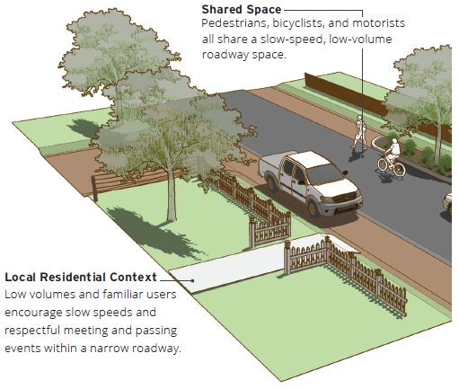
Mixed Traffic Facilities
Figure 3 - A Yield Roadway (adapted from Dickman 2016)
A low-speed neighborhood street with few cars traveling on it each day (AKA annual average daily traffic or AADT) might include minimal wayfinding signage or even no traffic control devices at all (not even double yellow lines or even sidewalks!). This type of road is called a yield roadway and it operates on principles similar to watercraft on open water. Larger, powered boats yield to smaller, human or wind-powered boats who yield to swimmers, as motorized vehicles yield to bicyclists who ultimately yield to pedestrians. Engineered variants of the yield roadway center on calming the speeds of the motor vehicle traffic by narrowing the roadway and visually demarcating multipurpose roadsides for parking or pull-outs with gravel, turf, or pavers. These types of roads will very rarely, if ever, serve as corridors for through-travel – they primarily serve local residents or terminate to destinations. Marking center lines in the travel area of a yield roadway is counterproductive and will reduce the desired “traffic friction” that is the hallmark of these routes.

Shared Lanes
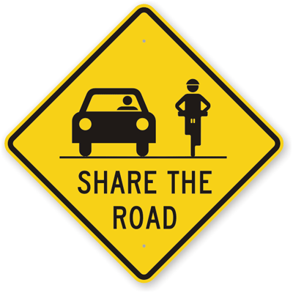
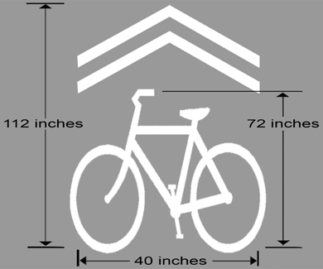
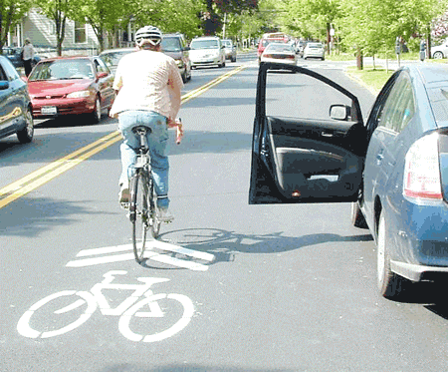
Increases in travel speed, AADT, and the presence of through-traffic justify additional traffic control devices in mixed-traffic situations. The most recognizable facilities you’ll see are called shared lane markings or sharrows. Sharrows include two parallel arrows (a chevron) and a bike symbol oriented in the direction of travel. They often accompany signs that read Bicycles May Use Full Lane.
Figure 4 - The principle components of the shared lane marking (left, FHWA 2009) as compared to the old "Share the Road" signs (middle, FHWA 2009) and an example of an installed sharrow in Ithaca, NY (Cornell 2009)
Chevron
Not Preferred
This combination produces a facility formally known as a shared lane and replaces an outdated campaign that both cyclists and motorists find confusing (Hess 2015). Transportation users often reported misinterpretations of the old “share the road” signs that are still present on some higher speed roads around town (like Rt. 705 and Don Knotts Boulevard). Sharrows work primarily to alert motorists to the possible presence of cyclists, increasing their levels of alertness. They serve an additional benefit by suggesting cyclists a safe position in the lane. You’ll find them usually in the middle of the lane, steering cyclists clear of roadside obstacles such as car doors or improperly-oriented drainage grates.

Bicycle Boulevards
In an ideal world, all major through-streets or arterials have parallel, alternative routes that can be turned into what’s known as a bicycle boulevard. These facilities prioritize cyclists through a diverse set of traffic calming techniques including sharrows, some of which can be seen in Figure 5. A bicycle boulevard type corridor will parallel University Avenue from Evansdale Drive to Stewart Street via Rawley and Jones Avenues.
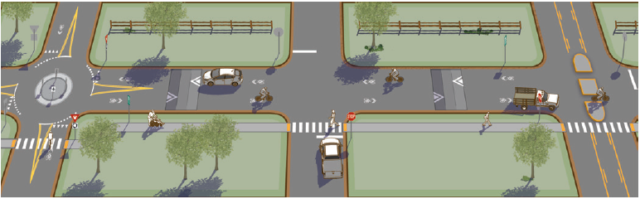
Figure 5 - A model Bicycle Boulevard with through-access prioritized for bicycles. Note the median to the far right preventing motor vehicles from using the street as a thoroughfare and the speed humps designed to slow average speed. (Dickman 2016)

Visually Separated Facilities
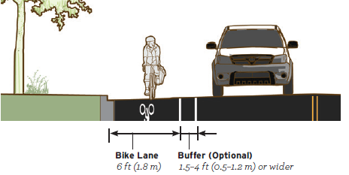
When calmer routes do not exist parallel to a corridor and/or when such routes include steep hills, the speed differential between cyclists and motorists may reach unacceptable levels. Speed differentials are simple measures of the difference in speeds between two vehicles. If the average cyclist travels at 12 - 15mph on flat ground and the average speed of a vehicle on a fast road is 25 - 30mph, the speed differential between the two is 10 - 18 mph. Excessive speed differentials are dangerous for everyone on the road and can lead to significantly more devastating crashes.
Figure 6 - A model bike land (Dickman 2016)

Bike Lanes
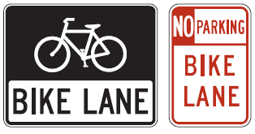
In these cases, and in other cases of high density and intense motor traffic where unused right-of-way is available, we elect to use facilities which begin to segregate cyclists from motorists. The most easily recognized version of these facilities is, of course, the bike lane.
Figure 7 - Signs often found in bike lanes (FHWA 2009)
Bike lanes come in all shapes and sizes, and some are even completely painted green to increase their visibility. All, however, share common components: a solid white line along the side of a roadway with the words “bike lane” and a symbol of a bicycle inside a strip of pavement typically 4-6.5’ wide that provide a refuge of exclusive space for cyclists. We often interrupt the solid line at intersections, with some facilities merging cyclists into mixed traffic prior to the intersection and others simply dashing the line and creating a type of intermittent advisory lane.
Morgantown may experiment with some of these exotic variants, but at the moment we are more concerned with correct, system-wide placement. The first bike lane to be installed in our city will serve an example of a well-known variant: the section of Jones Avenue from Stewart to Overhill will include a contra-flow bike lane that simultaneously serves as a climbing lane.
Contra-flow bike lanes are simply bike lanes that provide a means for cyclists to travel the wrong-way on one-way streets. Although potentially contrary to reason, the provision of exclusive space helps to allow cyclists to remain safe in these situations. They are often installed along routes already commonly used by cyclists and routes which allow cyclists to avoid heavy traffic or overly long travel. A quick trip down a one-way street for motorists might be an annoyance; it might mean significantly increased travel time and exposure to traffic for cyclists. Climbing lanes are simply bike lanes that are placed on steep uphill sections that may otherwise qualify as a shared lane but have excessive speed differentials.

Wide Outside Lanes
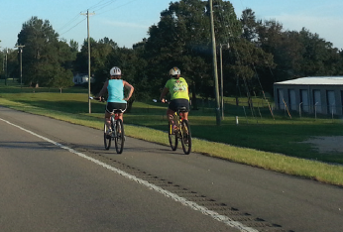
Bike lanes are not, however, the only type of visually separated facility. Paved, wide outside shoulders are another good example of visually separated facilities. Though lacking cycling-related symbols, these multi-use facilities still provide much needed refuge for cyclists, particularly on high-speed corridors. As the speed increases, the ideal width of the shoulder does too. Buffer areas and rumble strips also function to improve safety as speeds increase by further separating motorists and cyclists and providing immediate, audible and tactile feedback to both when they errantly enter into the other’s lane. You can find wide-outside lanes along Route 19 from the Star City bridge to 8th Street.
Figure 8 - A wide outside lane in Mississippi (Dickman 2016)
We hope this document provides a convenient reference for your questions on the new cycling infrastructure we’re installing around Morgantown. If you have any questions, please feel free to ask! Our city’s engineering department is happy to chat about new ideas or hear any comments you may have about these types of facilities. Additionally, the Morgantown Municipal Bicycle Advisory Board holds monthly, public meetings where they prioritize these investments. Show up and get involved!
Find out more information at www.bikemorgantown.com

References
Cornell (2009). Shared Lane Markings for Your Toolkit. Cornell Local Roads Program. Web. http://www.clrp.cornell.edu/nuggets_and_nibbles/articles/2009/shared_lane.html
Dickman, D. et al. (2016). Small Town and Rural Multimodal Networks (No. FHWA-HEP-17-024).
Dill, J., & McNeil, N. (2013). Four types of cyclists? Examination of typology for better understanding of bicycling behavior and potential. Transportation Research Record: Journal of the Transportation Research Board, (2387), 129-138.
Hess, G., & Peterson, M. N. (2015). “Bicycles may use full lane” signage communicates US roadway rules and increases perception of safety. PloS one, 10(8), e0136973.
FHWA (2009). Manual on Uniform Traffic Control Devices, Chapter 9C. Web. https://mutcd.fhwa.dot.gov/pdfs/2009/pdf_index.htm

